

**Nanyang Technological University**  
**Nanyang Business School**

BC3409/BC3415 AI in Accounting and Finance  
AY 2023/24, Semester 1

Group Project: Seminar Group 3

AI and Finance in SSS Bank collapse (Silicon Valley Bank)

**Investigating the Financial Crash of Silicon Valley Bank and the Usage of AI in Predicting and Detecting Market Risks and Conditions**

**(With Predictive Analytics and Python Codes)**

**Members:**

|  |  |
| --- | --- |
| **Name** | **Matriculation Number** |
| Lim Qing Rui | U2010816G |
| Amanda Ling Zhi Qi | U2022213G |
| Huang Jingyi | U2011981E |
| Adeline Soh Ziyi | U2110084J |
| Tay Wen Wei | U2110742C |
| Deionna Chee Rui Ping | U2021449D |

**Prepared for: Professor Teoh Teik Toe**

Executive Summary 3

1. Financial component 4

1.1. What were the primary factors that led to the collapse of Silicon Valley Bank? 4

1.2. Discuss the role of Silicon Valley Bank' exposure to the financial market in its collapse. 5

1.3. Explain the concept of leverage and how Silicon Valley Bank' high leverage contributed to its downfall. 6

1.4. Analyze the significance of liquidity in the context of Silicon Valley Bank' collapse. How did the lack of liquidity impact the firm? 8

1.5. How did the decline in market confidence affect Silicon Valley Bank' ability to recover from its financial challenges? 9

1.6. Evaluate the regulatory challenges that emerged during the Silicon Valley Bank' collapse. What were the key shortcomings in the regulatory framework? 10

1.7. Discuss the broader impact of Silicon Valley Bank' collapse on the few financial institutions of 2023. 11

1.8. Explore alternative scenarios: What could have been done differently to prevent or mitigate the collapse of Silicon Valley Bank? 12

1.9. Examine the lessons learned from the Silicon Valley Bank case and their implications for financial institutions and regulators. 14

1.10. Reflect on the ethical considerations surrounding Silicon Valley Bank' actions in the lead-up to its collapse. 14

2. AI Component 16

2.1. How can AI be utilized to predict and detect financial crises in advance? 16

2.2. What are the key AI-driven risk management strategies that financial institutions can employ during times of crisis? 16

2.3. How does AI enable real-time monitoring of market conditions and asset prices to make informed investment decisions during a financial crisis? 18

2.4. Can AI be used to identify potential fraudulent activities and mitigate risks in the financial sector during turbulent times? 19

2.5. What role does AI play in automating and streamlining financial processes to ensure efficiency and cost-effectiveness during a crisis? 20

2.6. How can natural language processing (NLP) and sentiment analysis be applied to analyze news and social media data to gauge market sentiment during a financial crisis? 21

2.7. In what ways does AI enhance credit risk assessment and help in managing non-performing assets during economic downturns? 22

2.8. Can AI-powered chatbots and virtual assistants assist customers and provide support to clients during a financial crisis? 22

2.9. How does AI-driven scenario modeling aid in stress testing financial systems and understanding their resilience in the face of economic challenges? 24

2.10. What ethical considerations should be taken into account when deploying AI in the financial sector during a crisis, and how can potential biases be mitigated? 25

3. References 26

4. Appendices 36

4.1. Appendix A: Data Dictionary 36

4.2. Appendix B: Data Exploration Graphs 41

4.3. Appendix C: Data Mining and Results 46

4.4. Appendix D: Code Snippets and Functions 51

# Executive Summary

This report examines aspects of Silicon Valley Bank’s (SVB) Collapse and how we can use Artificial Intelligence (AI) as a predictive analytics tool and in identifying, monitoring and helping stakeholders in financial crisis and Anti-Money Laundering (AML).

SVB had a high market capitalisation of USD$43.8 billion at its peak on 6 November 2021. However, as deposits poured in from venture capital companies and high net worth clients, the bank was unable to keep up with the influx of deposits and looked towards holding of long-term treasuries as a form of investment. However, throughout FY2022 and FY2023, the bank’s portfolio consisting of close to 50% Held-To-Maturity Treasuries began to face steep declines of 20% which led to a cumulative USD$15 billion in unrealized losses. As investors looked to withdraw deposits due to fears of low liquidity, this led to a realisation of USD$1.8 billion in losses from HTM securities, and the need to raise more funds for withdrawals, spiralling a series of increased withdrawals which were not met by the lack of adequate cash in the bank.

Hence, this report will focus on usage of machine learning models to predict factors that impact banks during and before financial crisis, where the group discovered that Capital Tier 1 Adequacy Ratio was a key factor contributing to bank defaults. In addition, GDP growth of the country and other liquidity metrics played a key role in determining the efficiency of the model during feature selection. Using this model, we can determine likelihood of the bank’s default and weight each factor to enhance predictability and discover trends to better explain reasons behind a bank’s default. In addition, we found out that SVB had a higher leverage ratio and lack of independent audit and compliance functions which led to their default. Regulators can look into enforcing this by setting up an audit taskforce for financial institutions in the future.

Using the quantitative insights from our random forest model, the group created a portfolio rebalancing model using Monte Carlo Analysis for various scenarios and stress-tested the assets and liabilities of SVB compared to peer banks such as Goldmann Sachs, Citibank, Morgan Stanley and Bank of America to spot and trends using linear regression. This was conducted to provide a data driven approach to predicting the default outcomes and determine lapses in regulations in the financial industry. Our key findings suggested that banks that default (SVB, First Republic Bank) faced greater number of positive coefficients and correlations between assets, liabilities and treasury rates, showing high sensitivity of the portfolio and lack of diversification. Hence, we suggest that regulators can look into data driven models targeting line items within financial statements as a form of stress testing and quantitative analysis to determine at-risk financial institutions such as SVB.

Using AI as a key driver for AML and client support tool is also critical for financial institutions especially in times of crisis. Our report investigated that the usage of AI is estimated to save $1.1 trillion in operation expenses. AI is an enabler to generate models and insights that would be missed by traditional stress-testing methodologies and to gauge market sentiment. This can be done by enhancing existing risk assessments and credit stress-testing using domain expertise from regulators and news sources, enhancing data collection capabilities. AI is also able to analyse large datasets, market conditions and economic indicators to determine inflections in trends in financial analysis and planning.

Using existing studies from PayPal and Google Cloud AML AI Model, we discovered that random forests was the most accurate and efficient at detecting presence of Money Laundering and fraudulent transactions. This was performed using transaction analysis. In addition, chatbots can be used to analyse customer sentiments and gauge sentiment on news related to banks and companies. This detective methodology is shown in several of the group’s models where we used Google PALM API and Sentiment analysis to create sentiment analysis benchmarks. The group acknowledged benefits and challenges of AI in this report, where we suggest several strategies in compliance and data protection in line with regulators to enhance governance over the usage of LLMs. This would lead to greater transparency and accountability in financial institutions.

These insights can be implemented into financial institutions internal and external strategies, such as enhancement of AML policies and staff trainings, as well as portfolio rebalancing and stress testing. Externally, this would restore confidence in the bank and increase compliance with regulators through a more comprehensive approach. We believe that this will improve liquidity and provide a better and holistic approach to mitigating financial defaults of financial institutions while addressing customer concerns.

# 1. Financial component

## 1.1. What were the primary factors that led to the collapse of Silicon Valley Bank?

Silicon Valley Bank (SVB) held long term investment securities that resulted in a liquidity crunch due to under-collateralization, as they had major losses of USD$1.8 billion on their current treasuries which they purchased due to excess cash inflow from depositors such as tech companies and High Net Worth clients that deposited their money during the Technology Boom in the pandemic. ***(Paul S., 2023)*** In addition, they did not manage liquidity risk through purchase of short-term treasuries/securities that offered higher interest rates and greater liquidity to meet short term withdrawals from depositors that hedged against their long-term holdings. The current redemptions (to meet withdrawals) of long-term treasuries meant that SVB had to realise USD$1.8 billion in losses from their USD$21 billion portfolio and had to be covered by capital raise through equity sale, which alarmed investors and depositors, resulting in a mass withdrawal (bank run), causing the bank to collapse. ***(Reuters, 2023)*** In comparison to previous years, SVB was overleveraged in FY2022 as they had higher Non-Current Asset to Total asset ratio of 4x higher compared to earlier years, 2x higher non-current liabilities coverage ratio and liquidity crunch as quick ratio decreased 30% compared to previous years. ***(Figure 1 and 2)***

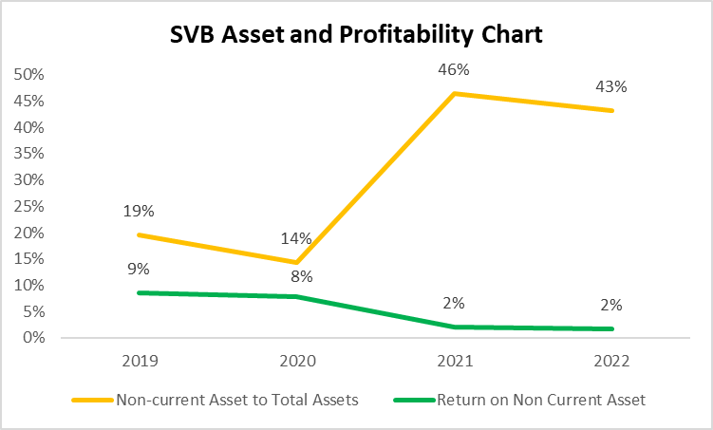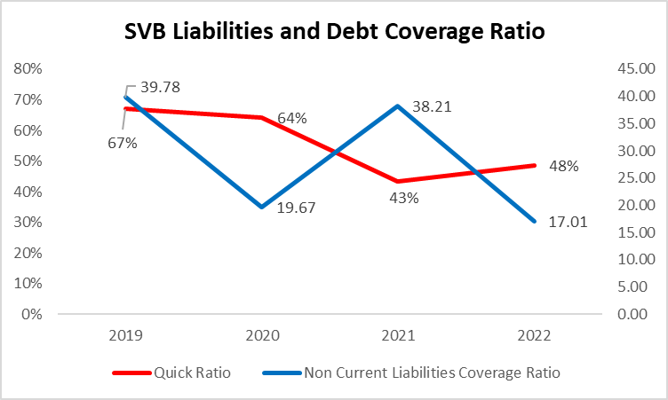

*Figure 1: SVB Profitability and Assets* *Figure 2: SVB Liabilities and Debt Ratio*

In addition, SVB Significantly increased their Long-Term Assets holdings (HTM Securities) to almost half their total asset portfolios in the past couple of years (2021-2022), leading to overleverage and lower liquidity in assets ability to repayment debtors or depositors. This was further exacerbated by the fact that their Non-Current Assets were yielding low returns of 2% per annum in recent years (Return on Non-Current Assets). ***(Figure 1 and 2)* *(USA SEC., 2022)***

These elements sparked fears of low solvency of the bank, causing investors, High Net worth Individuals and Technology Startup who had deposited their money to withdraw their cash holdings, while decreasing confidence in repayment ability of the bank resulting in lower ability to refinance the losses through equity sale. As little investors pick up on the equity sale, and more investors pull out of the bank. This resulted in widespread paranoia from investors and caused SVB to collapse.

***Comments:*** *See* ***4.4 Appendix D, Diagram A, Step 6*** *on a Random Forest Model where we discovered that Capital Tier 1 Adequacy Ratio is a key feature in predicting bank default. GDP and other macro-economic conditions are also able to predict probability of bank default too, alongside other liquidity metrics such as Quick Ratio. This analysis was performed using data from time periods where bank defaults primarily occur/financial crisis.*

## 1.2. Discuss the role of Silicon Valley Bank' exposure to the financial market in its collapse.

SVB's collapse significantly affected the Tech Startup ecosystem and High Net Worth Investors. SVB's expansion led to substantial deposits, including $5 billion from U.S. companies and additional credit facilities. Companies like Circle and BlockFI held reserves of $3.3 billion and $227 million, respectively, at SVB. ***(Reuters, 2023)*** However, thanks to prudent diversification, these firms held less than 10% of their assets in SVB and could rely on other sources to sustain their operations. Regrettably, some clients, like DocuSign and Upstart, had exclusive agreements with SVB and were restricted to depositing their funds only with SVB. ***(Rohan G., 2023)*** This has led to excess exposure to the collapse and leading to both investors in the companies and management seeking to withdraw funds, resulting in a mass bank run across all industry verticals and geography. Furthermore, in treasury markets (Bond markets), investors believed that the rate increase would slow down or be halted in March 2023, resulting in a 100 basis points drop in treasury yields as cash inflows piled into the purchase of treasuries and bonds, leading to prices increases in Fixed Income assets. Hedge Funds entered a massive, short/bearish position in 2-year treasury futures. Compounded with increased volatility and aftershocks from the market movements, the changes in prices of treasuries, yields and increase in short positions resulted in the deep inversion in treasury yields in 2-year treasury yields. ***(Carolina M., 2023)***

With the drop in Treasury Yields in ***Figure 3***, this increased equity/stock markets, despite the sustained rate volatility, as the S&P500 index pared its year-to-date gains and is up 2.83% as of 2023 after falling 19.4% in 2022. Investors' confidence piled back into the markets in anticipation of lower rates, pricing into the next Fed meeting in March and April 2023 that feds would slow down on rate increases.

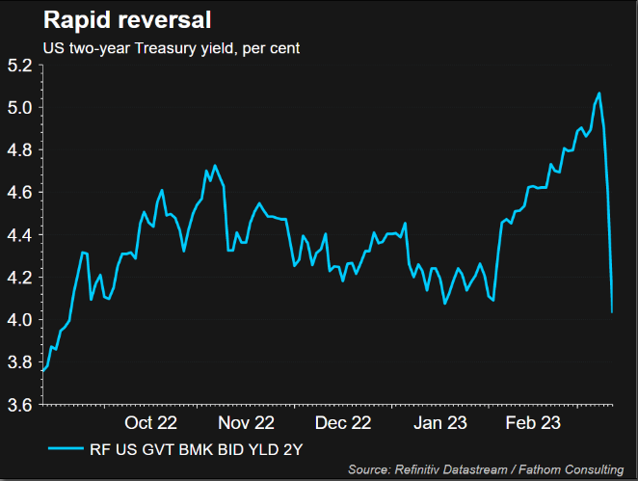

*Figure 3: Treasury Yield for FY2022 and 2023*

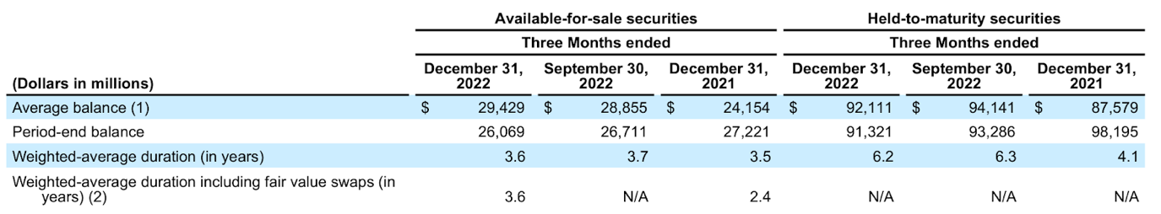*Figure 4: Weighted Duration of SVB’s HTM Securities*

Bonds also had an intense effect on the highly exposed asset composition of SVB. The fundamental principle underpinning bond investments lies in the inverse relationship between market interest rates and bond prices. Typically, when market interest rates increase, prices of fixed-rate bonds tend to decrease. Over the period from 2022 to 2023, the Federal Reserve (Fed) pursued an aggressive and swift course of interest rate hikes to counteract escalating inflation in the United States, elevating rates from 0.25% to 5.00% by the onset of the SVB crisis on March 10, 2023 ***(Tepper, 2023)***. By March 2022, approximately 42% of SVB assets were composed of Held-to-Maturity Securities (HTM), accounting for 78% of total securities—a proportion nearly double the average leveraged buyout (LBO) as outlined by the Federal Reserve ***(Federal Reserve, 2023)***. This configuration exposed the bank to significant interest rate risks. Referring to ***Figure 4***, the weighted average duration of HTM experienced a notable increase of 2.1 years, constituting a rise of over 50% from 2021 to 2022, concurrent with the Fed's interest rate hikes ***(SVB, 2022).*** This metric represents the average time required for SVB to receive all the bond's cash flows and signifies an escalation in risk.

Consequently, as the Fed augmented its interest rates, the duration of securities held by SVB extended due to the negative convexity of HTM (MBS) bond duration, amplifying the rate at which bond prices declined with increasing yields ***(Chen, 2023)***. Moreover, SVB failed to employ risk mitigation strategies such as hedging and diversification of its portfolio ***(Atkin, 2023)***. These factors culminated in a significant loss of 15 billion dollars by Q4 2022 ***(Federal Reserve, 2023)***. Compounded by a widespread tech industry layoff trend, which notably impacted SVB's primary customer base of start-ups, the bank faced increased cash withdrawals. To meet these demands, SVB was compelled to sell off bonds, necessitating reclassifying these assets to "available for sale" (AFS) rather than HTM. This shift had dual implications: firstly, the bonds were marked down on SVB's financial statements, and secondly, actual sales crystallised the losses ***(Oattree, 2023)***. Recognising these losses expedited the dissemination of adverse rumours throughout the close-knit venture capital community, triggering further withdrawals.

Lastly, gold prices had a surge since the SVB’s collapse. Gold has traditionally been seen as a safe haven; it holds its value longer than any other investment type, making it a stable hedge against inflation. With a drop in confidence in the Traditional Finance and Banking sector, people choose to buy gold to protect their capital against value erosion. That resulted in gold prices to climb 2.4% in March 2023, marking their biggest monthly increase since January 2023.

## 1.3. Explain the concept of leverage and how Silicon Valley Bank' high leverage contributed to its downfall.

Leveraging is to use borrowed capital as a funding source when investing to expand the firm's asset base and generate returns on risk capital. It is observed that SVB had a higher debt leverage due to higher operating leverage compared to most banks, where debt holdings (Mortgage-backed securities) were half of their balance sheet due to the influx of deposits from their depositors (USD$91 billion compared to USD$189 billion), while most banks had only ¼ of holdings in debt assets and were constantly loaning out deposits to earn interest income. ***(Marc J., 2023)*** This resulted in a high debt-to-asset ratio, leading to higher leverage ratios of 13.2x compared to Singapore Banks of 11.6x, as more debt is used to finance operations and asset returns. By being overexposed to the Bond markets (as they purchased > USD$91 billion in treasuries and overleveraging through debt), this reduced balance sheet capacity for withdrawals. This was further exacerbated by the fact that 94% of SVB deposits were not insured by FDIC (Federal Insurance) as many deposits exceeded $250,000 threshold of the FDIC limit. ***(Howard M., 2023)***

Due to SVB’s heavily exposure to the technology industry. ***(Kesavan B., 2022)*** When the technology sector began to struggle in 2022, the value of SVB's loans to tech startups also decreased. This strained SVB's balance sheet and made it difficult for the bank to raise new capital. That made SVB vulnerable to a bank run. When depositors started withdrawing their money from the bank, SVB was unable to meet their demands. This forced the bank to file for bankruptcy.

Furthermore, the industry standard for Tier 1 risk-based capital is 8.5%, which is used as a gauge that the bank can withstand shocks from negative economic losses and financial events through bank reserves, investments that were used to fund business activities for the bank’s clients. ***(James C., 2020)*** Despite SVB having a capital adequacy ratio of 15.4% (2x higher than industry requirements) which shows that 15.4% of the bank’s capital can meet short term liabilities and risk-weighted assets, this was overlooked by market investors who failed to see that the extreme high leverage of the bank’s Tier 1 adequacy ratio was masked by a higher risk-based capital of 16.18% (due to illiquidity of assets E.g. Bonds) in treasury assets. ***(Carl A., 2023)*** This risk-based capital was 50% higher than the required ratio of 10.5% for large banks, from non-sticky treasuries that the bank held which was highly dangerous in the rising interest rate macro environment.



*Figure 5: Risk Based Capital Ratio*

Lastly, in the banking sector, the leverage ratio is a crucial metric to evaluate a bank's financial standing concerning debt, capital, and assets. According to Figure 5, the leverage ratio for SVB indicates that for every $12.09 in common equity tier 1 capital, there is $100 in risk-weighted assets. In pursuit of profit, it allocated a significant percentage of its capital to Mortgage-Backed Securities (MBS), denoted as Held to Maturity (HTM) on the balance sheet. This approach allowed SVB to convert a relatively low return on assets into a higher return. However, a significant concern arises from maintaining a high ratio of total assets to equity capital, as a slight dip in asset values could erode the bank's equity, potentially rendering it insolvent. Substantial leverage and an asset/liability mismatch represent a highly precarious scenario in any sector ***(Oattree, 2023)***.

Although a high leverage ratio is not inherently harmful, it does pose considerable risk. In a crisis and ensuing bank runs, SVB may lack sufficient equity to cover incurred losses, thus precipitating its decline. Ultimately, this implies that SVB reserved inadequate funds to self-finance during a financial crisis.

***Comments:*** *As shown in Figure 6, SVB had a lower net efficiency ratio compared to peer banks. With an Efficiency Growth rate of -0.001328 across 75 quarters observed, SVB was unable to utilise assets efficiently when compared to other financial institutions. Using a T-Test, we found that due to negative performance, a suitable 95% confidence interval or threshold for efficiency growth cannot be found for SVB. The threshold of -0.00041708 when compared to other banks suggest that if SVB’s threshold is above the value above, the bank’s efficiency has deteriorated over the periods investigated. Hence, using efficiency rate thresholds, we can see that SVB has decreased efficiency ratio and is underutilizing return on their assets compared to peer banks.*

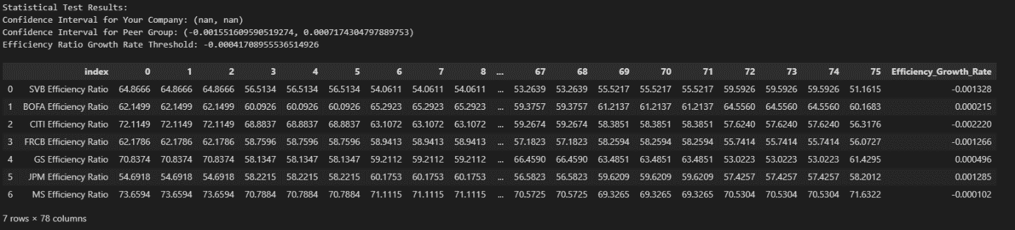*Figure 6: Comparison of Banks’ Efficiency Growth Rates*

## 1.4. Analyze the significance of liquidity in the context of Silicon Valley Bank' collapse. How did the lack of liquidity impact the firm?

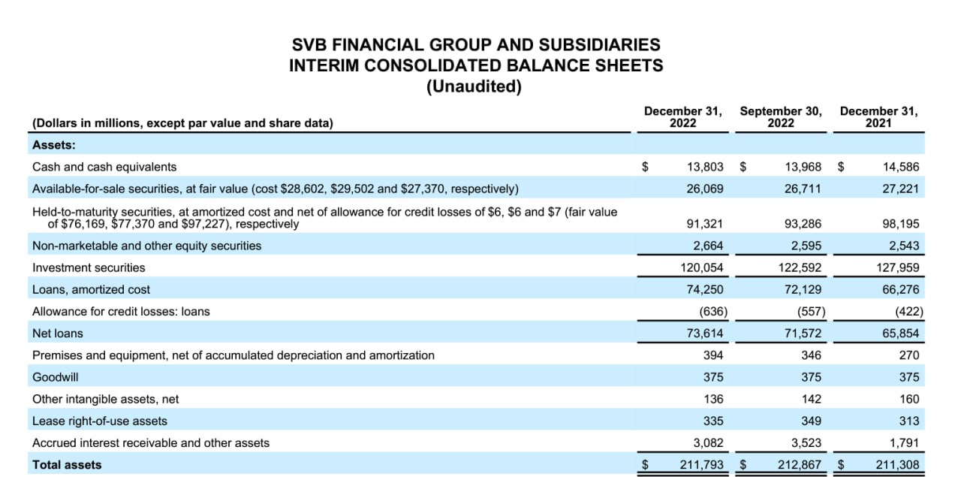

*Figure 7: SVB Balance Sheet Asset*

A notable deficiency in liquidity within SVB stems from an overemphasis on Held to Maturity (HTM) securities within its investment portfolio. The examination of SVB's balance sheet in Figure 7 indicates that the combined proportion of cash/cash equivalents and Available for Sale (AFS) securities is a mere 18.8% of the total assets ***(SVB, 2023)***. Consequently, this signifies that, at any given juncture, the available cash for withdrawal is limited to only 18.8% of the total capital. Although it is acknowledged that HTM assets can be sold, it is crucial to understand that this course of action would crystallize a substantial $15 billion loss incurred during the fiscal year 2022. Presently, SVB is grappling with a precarious financial situation, lacking the essential financial resources to offset this significant loss.

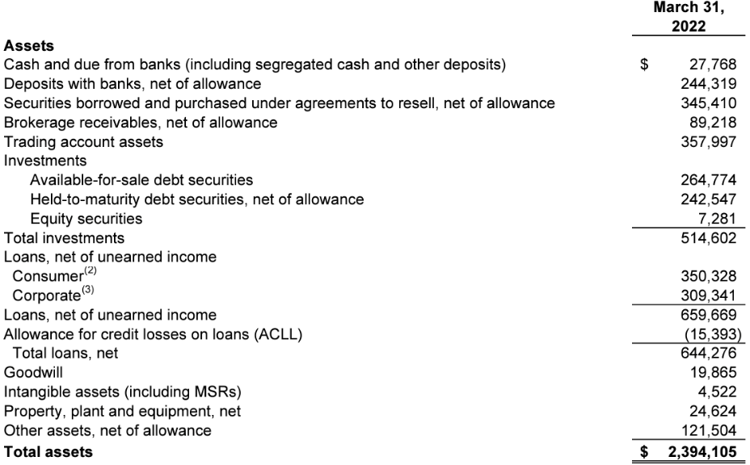

*Figure 8: Citi Bank Balance Sheet Asset*

Conversely, examining Figure 8 reveals a more favourable liquidity position. Citibank's easily liquidable assets, constituting the first six categories under Assets, make up 59% of its total assets ***(Citi, 2022)***. In contrast to SVB's 18.8%, this substantial proportion in Citibank's asset base positions it to navigate bank runs with significantly greater ease over a 30-day stress period.

## 1.5. How did the decline in market confidence affect Silicon Valley Bank' ability to recover from its financial challenges?

With the rising high interest rates macro-environment, this impacts banks’ ability in lending cash and decreases net interest income due to lower loan demand as the cost of capital increases. This increases the financial and operating leverage of the bank, where they need to put more money to work in order to maintain the ability to pay back debtors and creditors, further spiralling into increasing the default probability of banks with an increasing inability of banks to service debt repayments. ***(Charles S.M., 2015)***

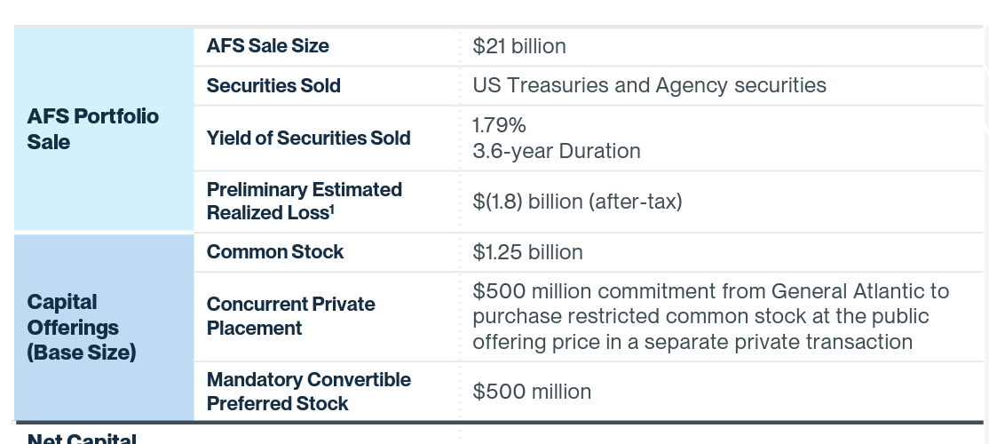

*Figure 9: SVB - the Strategic Actions/Q1’23 Mid-Quarter Update SVB*

With reference to Figure 9, the release announced that 21 billion dollars’ worth of bonds will be sold off with a preliminary realised loss of 1.8 billion dollars ***(SVB, 2023)***. Further, at the same time, it issued new shares worth USD$1.25 billion and more to finance USD$2.25 billion dollars for SVB. This indicated to the market that SVB had made significant losses in the past FY, they resorted to an equity Issue as a desperate measure to raise capital to cover their loss from treasuries sell-off and loss realisation. An equity issue is typically seen as a positive move, but in this scenario, it decreases overall EPS due to higher number of shares involved. In perspective, Earnings per share (EPS) is $28.27 before the equity sale, but the dilution in outstanding shares would result in a 13% decrease in EPS for shareholders, which is a $24.90. ***(USA SEC., 2023)*** The dilution in available capital will result in a lower profit distribution to shareholders and results in the company being less attractive to investors, hence driving a mass sell-off and decreasing share price.

SVB was commonly used by venture capital backed businesses and cited that one of the reasons it was seeking new funding was customer cash burn. However, it had become increasingly challenging for early-stage enterprises to secure more capital due to rising interest rates, recessionary fears, and a downturn in the market for initial public offerings. To repurpose the capital from SVB and hedge against downturns, businesses withdrew their bank deposits at institutions like SVB. Lower cash inflows from Depositors (Early-Stage Tech companies) meant lower deposits were available to pay back other depositors. This resulted in a waterfall effect as other companies were reluctant to deposit money in SVB, and more businesses withdrew their deposits.

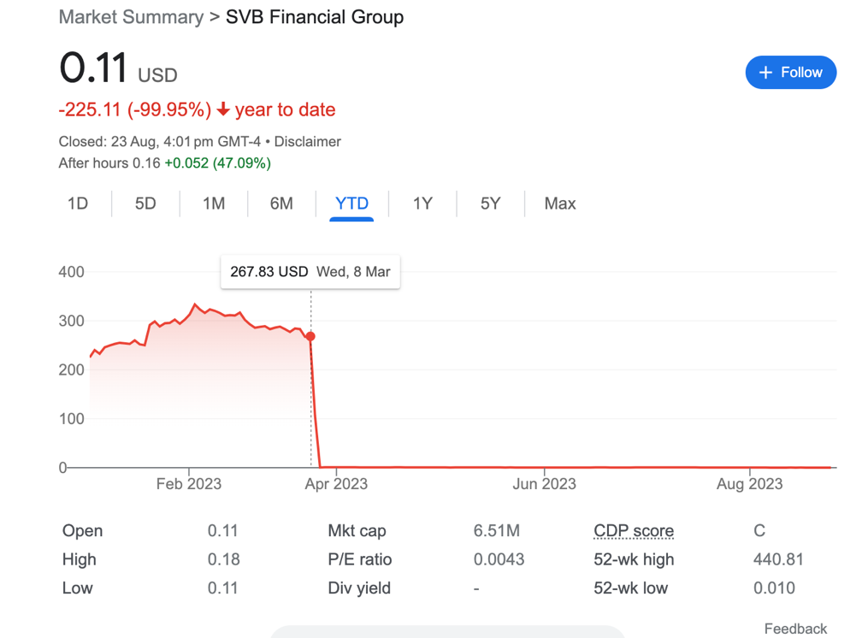

*Figure 10: SVB stock price*

This report was released on March 8th. From Figure 10, a 60% drop in share price indicates that the market no longer had confidence in SVB, and thus, more startups withdrew money from SVB, leading to a bank run.

## 1.6. Evaluate the regulatory challenges that emerged during the Silicon Valley Bank' collapse. What were the key shortcomings in the regulatory framework?

Before the SVB collapse, the regulators were not doing enough to oversee the bank. SVB was one of the biggest banks and had received a high regulatory rating. However, regulators may not have been aware of the full extent of the bank’s exposure to risk. SVB was highly leveraged, with a debt-to-equity ratio of consistently more than 10 since 2020, this makes the bank more vulnerable to losses if their investments went sour ***(Conerly, 2023)****.*SVB also need stronger risk management practices. The bank’s investment portfolio was heavily exposed to interest rate risk and was not sufficiently mitigated.

After the collapse, there are regulations such as the clawback of executive compensation. It is to allow regulators to recover executive compensation that was paid out in the years. However, nobody can justify how widespread the clawbacks will be and how far back in time we should go ***(William C., 2023)****.* Social media quickly and significantly negatively impacted the American financial crisis, which then quickly extended to markets in Europe and the G-7 as it hampered the depositor’s confidence. Given the strong influence nature of social media, regulatory organizations need to intervene right once a bank run happens, to prevent the crisis from spreading to other sectors and regions ***(Macheel, 2023).*** These actions would prevent a systemic collapse and promote investor and depositor confidence.

A radar chart analysis of the SVB in Figure 11 shows key gaps in the liquidity and management quality of the bank, as well as Financial and Asset management issues. The current regulations do not comprehensively judge and benchmarks banks to each other, which should be performed for Financial Institutions to understand their compliance standards with regards to that of competitors. Using a radar chart, we can see that although SVB performed poorly, we can still perform a horizontal analysis when comparing SVB with its’ peers and understand disparities in financial compliance, management, and liquidities of banks for a more comprehensive outlook.

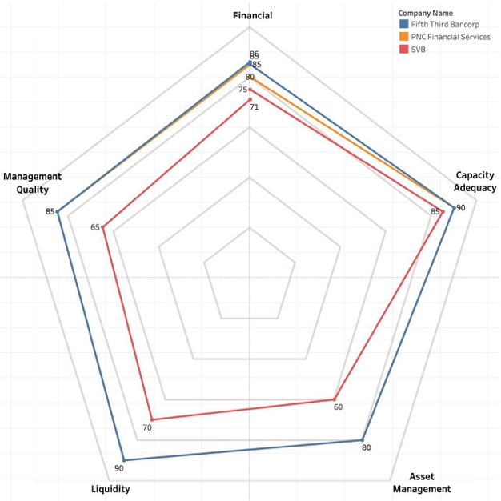

*Figure 11: Radar Chart of SVB in relation to 2 other competitors*

## 1.7. Discuss the broader impact of Silicon Valley Bank' collapse on the few financial institutions of 2023.

The downfall of SVB, Silver Gate, and Signature Banks had significant repercussions for the banking sector and broader financial institutions. It triggered a panic, with consecutive bank collapses dominating headlines for weeks, leading to a full-fledged credit crisis, particularly affecting smaller banks. This crisis revived memories of the 2008 financial crisis and eroded depositor confidence in small to medium-sized American banks' risk management capabilities. Signature Bank, hit hard by the crisis, experienced a massive $20 billion withdrawal on March 10, just days after SVB's collapse, and closed its doors on March 12. This prompted a trend of bank runs at smaller banks as clients moved deposits to larger institutions like JPMorgan Chase and Citi, perceived as safer havens. These large banks quickly adapted to accommodate the influx of new clients.

Increased legal scrutiny and credit testing aspects of SVB’s collapse will impact other banks as the Federal Reserve (Feds) intend to appoint an independent regulator and auditor to scrutinize banks and their holdings. This will be done in several ways: ***(The Conference Board., 2023) (Michael S.B., 2023)***

1. To enhance financial system resilience and address bank crisis readiness under BASEL 3 requirements, regular stress-testing of assets became a norm. Large banks like SVB, JP Morgan, Goldman Sachs, and Morgan Stanley, with over $50 billion (about $150 per person in the US) in average weighted short-term funding assets, had to decrease these holdings to 70% of the $50 billion threshold. These assessments occur monthly.
2. Resolution Planning: Supervisors now require more financial institutions to engage in planning for asset coverage during failures, with macro environment scenarios updated every two years. These customized plans, under the IDI (Insured Depository Institution) rule, prioritize honoring letters of credit, qualified financial contracts for traders, and debtors, ensuring creditors are paid in the event of liquidation.
3. Capital Planning: Firms must use supervisory stress tests to identify idiosyncratic risks. They need to submit mid-cycle stress tests based on asset allocations (e.g., Tech investments, Treasury holdings) to prevent firm-specific risks. This ensures adequate capital buffers for various macro-environment scenarios. Hedging and risk mitigation accompany supplementary leverage ratios to maintain capital conservation buffers and sufficient cash flows, even with a countercyclical capital buffer requirement raised above 2.5% for high credit scenarios.

## 1.8. Explore alternative scenarios: What could have been done differently to prevent or mitigate the collapse of Silicon Valley Bank?

The collapse of SVB could have been mitigated through better risk management strategies such as diversification of assets by both depositors and the SVB themselves, creation of a risk management department and an active risk officer presence and liquidity and cash management planning.

1. Depositor Asset Diversification: To mitigate the risk of bank collapse and ensure retrievability of their deposits within the FDIC-insured limit of $250,000, depositors can diversify their holdings across multiple banks. This reduces the need for banks to rely heavily on these assets for revenue, while also increasing depositors' chances of recovering a higher portion of their assets in the event of a bank default, as exemplified by the defaults of SVB and Signature Bank. (Sophia R., 2023)
2. Asset Diversification at SVB: To reduce market risk exposure and asset portfolio volatility, SVB should allocate less than 20% of its assets to a single investment category (e.g., Equity, Treasuries, Bonds, Currency). By diversifying across various financial instruments, SVB can lower overall market exposure, enhance liquidity, and better align with the efficient frontier curve in asset management. Instead of heavily relying on 10-year treasuries, SVB could employ short-term treasuries to match interest rates and generate short-term yields, mitigating overleveraging. ***See Appendix 4.4 Part B for a quantitative analysis of Yield Curve and Asset Allocation of SVB’s current assets and portfolio rebalancing***
3. Risk management department and oversight: SVB did not allocate key personnel leading up to their solvency crisis. The risk management oversight led to a decrease in the bank’s ability to hedge and monitor risks, especially when the Feds were aggressively hiking interest rates. Key personnel could have been appointed as Risk managers to identify and spot risks before critical leverages occur. In addition, risk managers would be able to identify shortcomings through credit stress tests and development of quantitative frameworks to generate default scenarios using tools such as Monte Carlo simulations or Risk-Weighted Assets models. (Sophia R., 2023) (Jayantha S., 2023)

***Comments:*** *Figure 12 shows that SVB’s Total assets, short term and long-term investment and Held-to-Maturity assets has showed positive correlations to short term and long-term treasury assets (3 months bills, 12 months notes, 5-year notes, 30-year notes, etc). This shows high sensitivity of their assets to market conditions and in a rising interest rate environment, result in a decline in market value. A broader implication is decreasing asset prices (such as SVB’s decreased asset prices in their Held-to-Maturity asset valuations) when interest rate rises. This is shown in the case, where SVB did not meet investment returns and had to liquidate their assets at a loss.*

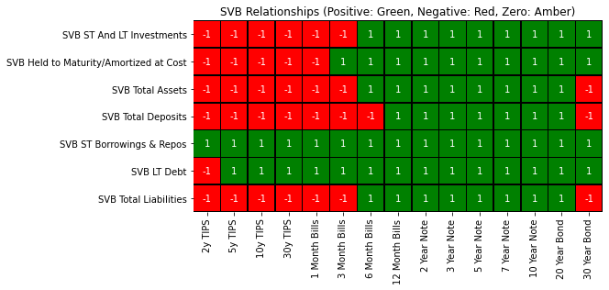

*Figure 12: SVB Relationships*

*Monte Carlo Simulations can help to rebalance portfolio allocations using different scenario analysis. In the example here in Figure 13, we simulate various asset prices using interest rates and price changes. Using pre-determined specifications such as* ***expecting returns of 20%,*** *accounting for* ***changes in macro environments****, we can simulate various asset classes movements using* ***historical returns and deviations in prices*** *to determine rebalance of portfolio. This allows us to account for various scenarios and find optimal asset allocation that is resilient to macro-economic conditions to optimise returns and lower volatility/exposure of the portfolio to shocks.*

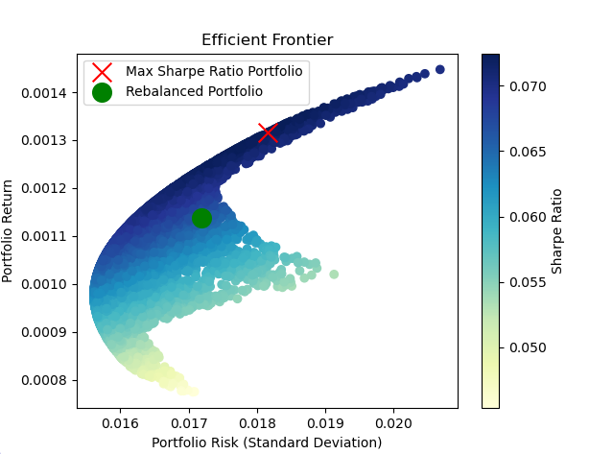

*Figure 13: Rebalance of Portfolio via Monte Carlo Simulation*

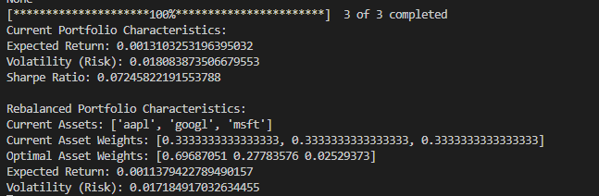

*Figure 14: Example of Monte Carlo Simulation*

1. Liquidity and cash management planning: Understand liquidity needs in Scenario analysis is a key driving force to ensure the operational efficiency, maintain optimal operating leverages and financial leverages where possible. SVB needed to abide by key regulatory frameworks and portfolio management strategies as they had 90% of their deposits uninsured by the FDIC due to a cash influx from commercial depositors. Strategic initiatives by SVB could include securing these deposits with other banks and conducting Financial Planning and Analysis (FP&A) in accordance with scenarios. During macro-economic crisis, SVB can also increase the cash that they hold by diversifying into short-term liquid assets to ensure that sufficient cash is available to meet depositors and creditors' needs. This allows them to plan for contingencies and large-sum withdrawals.

## 1.9. Examine the lessons learned from the Silicon Valley Bank case and their implications for financial institutions and regulators.

The main cause of SVB's failure was its subpar risk management procedures. The first mistake was making significant bets on Treasury bonds at a period of low interest rates. SVB reported $120 billion in investment securities as of the end of 2022, accounting for 55% of its assets, which is more than double the average for all U.S. banks ***(Eisen B., et al, 2023)*** In 2022, interest rates climbed sharply, and while bond portfolios, yields, and prices went in the other direction, those assets lost value. SVB had to take action to staunch the bleeding when such unrealized gains began to affect the balance sheet, notably via accumulated other comprehensive income or loss (AOCI) in the case of equity investments. From this, the financial institutions can learn to have a robust risk management practice in place **(*Rossi, 2023).***

This also indicates the need for more regulatory control particularly for banks operating in high-risk industries or challenging markets. To find potential weaknesses, regulators should have access to detailed information on a bank's risk exposure and operations.The stability of the financial system can be ensured through routine stress testing and evaluation of risk management procedures.By increasing the agility of supervision, it allows them to quickly detect and manage issues. As a result, authorities must be able to recognize and evaluate threats more rapidly and take appropriate action. This may be achieved by stepping up the quantity and quality of audits, employing more advanced data analytics, and collaborating closely with banks to assess and reduce risks.

## 1.10. Reflect on the ethical considerations surrounding Silicon Valley Bank' actions in the lead-up to its collapse.

Greed is a strong motivator that may influence individuals to take chances they otherwise would not. It is the greed that contributed to the bank's choice to take on too much risk in the instance of SVB. The management of the bank have been driven by a desire for large profits, even if it meant increasing risk. In the financial sector, it encourages the bank to take on excessive risk to maximize earnings. Among the detrimental effects of greed include financial crises, a decline in investor confidence, and liquidity issue of the bank. To reduce the dangers brought on by greed, regulators and financial institutions must take action. To achieve this, the regulatory environment can be strengthened, corporate governance can be improved, transparency and accountability can be promoted, and the public and investors may be made aware of the risks associated with greed **(Turak, 2023).**

We may contribute to the development of a more reliable and long-lasting financial system by doing these actions. Ethical concerns have surfaced within SVB bank following the revelation of additional information surrounding its collapse. Internally, Greg Becker, the CEO, and his CFO, Daniel Beck, divested their SVB stock just days before the collapse, well in advance of the public release of the Q1 SVB report. Notably, their stock was sold to purchasers and institutions who had faith in the inherent value of SVB. This situation has raised red flags associated with insider trading, a practice that is widely recognized as both unjust and detrimental to fostering market participation among the public **(Weinstein, 2023)**.

This case underscores the fact that individuals in positions of authority derived benefits from the hardships experienced by numerous others. It has thus triggered ethical and legal inquiries into their actions.

Leading up to the collapse, no communication was extended to shareholders regarding the risk associated with the mounting interest rates within SVB's portfolio. The CEO reportedly assured clients that it was 'business as usual' and that there was no cause for concern, all while concealing the significant losses amounting to billions of dollars **(L. 2023, March 15)**

# 2. AI Component

## 2.1. How can AI be utilized to predict and detect financial crises in advance?

AI is being used to analyse market conditions, trends, and economic indicators to forecast financial crises. Its advanced forecasting techniques and ability to analyze large datasets enable the identification of threats and opportunities. This enhances decision-making and risk management, allowing companies to identify early warning signs for financial crises. Real-time data updates enable financial institutions to manage risks and mitigate the impact of crises ***(Moretto, 2023)***.

Another example would be scenario analysis which utilizes the capabilities of AI and ML to generate potential business scenarios, considering factors like market trends and consumer behaviour. This leads to a more accurate and reliable forecast of realistic simulations. For example, nosiness can gain valuable insights into future market dynamics by examining the market data, predicting interest rates and inflation, and forecasting changes in key variables. This proactive approach empowers organizations to enhance their readiness for different circumstances, fostering resilience and adaptability amidst uncertainty ***(McKeown, 2023)***.

## 2.2. What are the key AI-driven risk management strategies that financial institutions can employ during times of crisis?

Risk management is an area of risk assessment, evaluation and control for the organization's capital and its earnings concerning Financial, Legal, Strategic and Security Risks ***(IBM, n.d.)***. An example of cyber or security risk management would be Safe Security, a cybersecurity company, that collaborated with large brands such as KFC, Netflix, SAP and Maersk to offer a system that integrates attack signals in real-time. Their product is called “The Safe ROSI Calculator”, ROSI essentially stands for Return on Security Investment Calculator. The calculator helps assess the cyber risk and calculate the return on security in real-time, ensuring the highest return. This tool also constantly learns new information to adapt to market changes, ensuring accurate credit decisions ***(ROSI, n.d.)****.*

Financial institutions are also using AI for market risk assessment. According to Barclay Hedge’s Fund Sentiment Survey, it was discovered that more than half of the respondents utilized AI in their investment decisions ***(Salvage, 2019)***. For example, BlackRock uses AI/ML technology to facilitate their investment process by developing mathematical models to analyse datasets to identify trends as a part of input into the decision-making for companies with respect to their investment. They also adopt the use of smart beta portfolios which have the flexibility to utilize different strategies when allocating weights within an index, thereby favouring specific attributes such as sustainable dividends or low volatility ***(BlackRock, 2019)***.

Low-volatility smart beta strategies have proven to outperform market capitalization-weighted indexes while reducing portfolio volatility and improving risk-return profiles without sacrificing upside potential. They are also used to build portfolios more aligned with the investor’s risk appetite. With reference to Figure 15, an example was also provided showing how the investors who anticipated a strong recovery in the US equity market would like to enjoy a degree of downside protection and maintain as much upside beta as possible with the performance statistics of this blended portfolio ***(Ung, 2019)***.

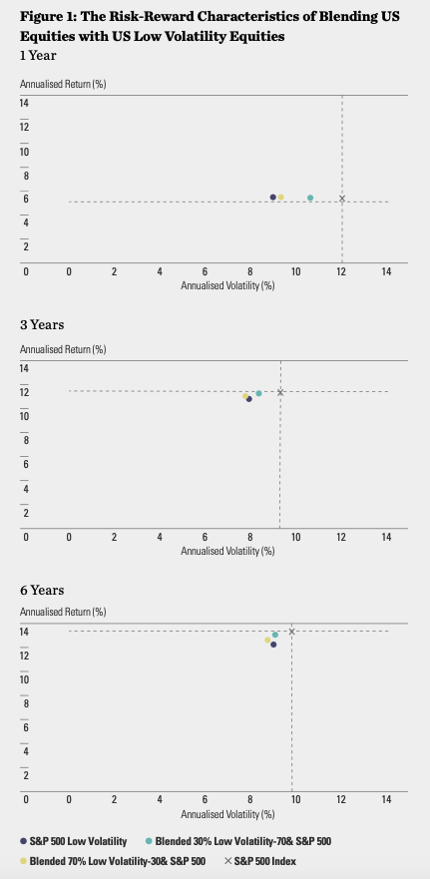

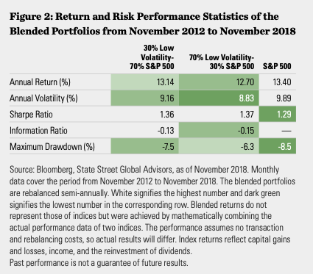

*Figure 15: Results of low volatility smart beta portfolios* ***(Ung, 2019)***

## 2.3. How does AI enable real-time monitoring of market conditions and asset prices to make informed investment decisions during a financial crisis?

According to McKinsey, it is projected that the technologies associated with the Fourth Industrial Revolution (4IR) will generate $3.7 trillion by 2025. These technologies include machine learning, automation, predictive analysis, and the Internet of Things (IoT). Businesses that have embraced AI have witnessed cost reductions ranging from 10% to 19% along, with revenue gains ranging from 6% to 10% ***(Mewari & Kamath, 2021)***.

A technique used is algorithmic trading which is essentially using algorithms to automate the trading process, with reference to Figure 16. This technique has become more prevalent in asset management ***(Kirilenko and Lo, 2013)***. The analyst will use the historical stock and market data to predict the future return of assets. Some benefits that AI offer includes collecting large amount of data simultaneously, assisting trade execution, and generating more insightful financial analysis alongside the integration of ML and quantitative finance. Lastly, it also follows for real-time market tracking and decision-making using Artificial Neural Network (ANNs) ***(Bartram, Branke, & Motahari, 2019)****.*

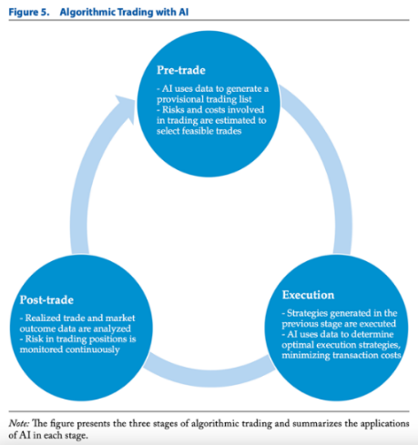

*Figure 16: Functions of AI in Algorithmic Trading* ***(Bartram, Branke, & Motahari, 2019)***

Another technique would be sentiment analysis. Research was conducted based on how sentiment analysis could assist in predicting market volatility. It went into great depth about using news article headlines and social media posts to influence the prediction of volatility levels. With reference to Figure 17, the study showed that sentiment derived from headlines can be a predictive signal for market returns with an accuracy rate of 65%, while tweets showed a strong negative correlation between positive sentiment and market volatility, indicating positive sentiment flow at the top is consistent with reduced market volatility ***(Deveikyte et al., 2022).***

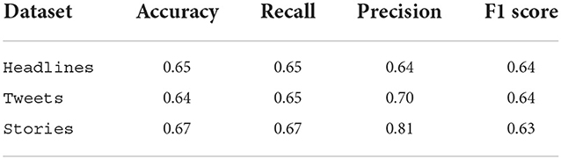

*Figure 17: Summary of results* ***(Deveikyte et al., 2022)***

## 2.4. Can AI be used to identify potential fraudulent activities and mitigate risks in the financial sector during turbulent times?

According to McKinsey, worldwide losses from card theft have nearly doubled over the past ten years, and by 2025, they are projected to reach $44 billion ***(Orecchio, 2022)***. The key challenge of this threat is its ubiquity, making it difficult to thoroughly review and identify potential fraudulent activities across all transactions. This process can be extremely time-consuming and labour-intensive. Artificial Intelligence (AI) and Machine Learning can help predict fraud even before it occurs by scanning for indicators and flagging suspicious activities. These technologies can also detect patterns in customer behaviour and reduce financial loss exposure, enhancing its security, as seen in Figure 18 ***(Owczarek, 2022)***.

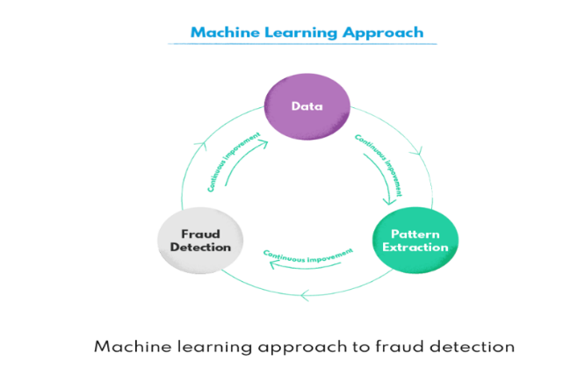

*Figure 18: Machine Learning adopted into fraud detection* ***(Owczarek, 2022)***

A real-life case of an AI and ML-supported fraud detection system is PayPal. PayPal created its solution called “PayPal Fraud Protection”, which is a machine learning solution that adapts and evolves to help merchants identify frauds and acts as a risk management solution for enterprises. This solution allows a thorough risk analysis based on the PayPal 2-Sided Network, a robust data source of transactions from the past 20 years. The intelligence of the solution allows it to be quick to identify the rapidly changing fraud patterns and with machine learning, it can assist with real-time data modelling ***(Paypal, 2021)***. According to LexisNexis, a risk solution company, it was reported the PayPal’s fraud rate is below the industry average of 1.86% ***(Owen, 2022****).*

Due to the increasing frequency of illegal activities, combating money laundering has also become increasingly crucial for businesses and financial institutions. An example of how AI can help would be the utilization of the Google Cloud AML AI model. It will monitor transactional data by employing various methods, such as machine learning algorithms, statistical analysis and data visualization. The model identifies money laundering and suspicious behaviour by evaluating data from various sources, such as financial transactions, client profiles, demographics, and transaction patterns. The model detects irregularities in transactions, helping financial institutions and regulatory authorities adhere to anti-money laundering regulations and strengthen their defences ***(Understand the AML Data Model and Requirements, n.d.)***. A company that adopted this system would be HSBC, which led to a 40% reduction in compliance check time while significantly enhancing the accuracy of its AML program ***(Artificial Intelligence and Anti-Money Laundering, n.d.***). Another method would be to use predictive modelling techniques such as Logistic Regression, Random Forests and Gradient Boosting. A study was conducted with the usage of the IBM Synthetic Financial Data Money Laundering dataset, which contains transactional information that could be used in the AML process. Each transaction was labelled in various step in the Money Laundering Process, and the transaction flows were analysed to determine the typical amount of money that will be used in Money laundering, as well as the number of layers that Money Laundering would usually have. Based on the end result, with reference to Figure 19, **Random Forest was proven to be the model with the highest accuracy rate,** however, it was pointed out that the recall score was not high enough to dictate it is able to correctly identify all the occurrences of money laundering. Thus, the authors suggested further analysis and study using a more diverse dataset but they did prove that predictive models do uphold a certain level of potential and ability to detect money laundering activities ***(Torres, 2023***).

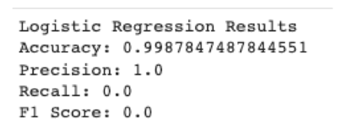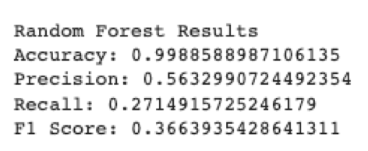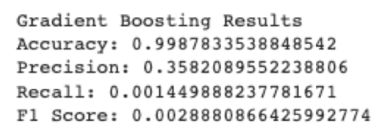

*Figure 19: Results of the three predictive models (Logistic Regression, Random Forests, Gradient Boosting)* ***(Torres, 2023***)

## 2.5. What role does AI play in automating and streamlining financial processes to ensure efficiency and cost-effectiveness during a crisis?

According to Bain & Company, the use of AI can help banks save around $1.1 trillion in operation expenses ***(Joyce, 2022)***. The use of AI spans across the Front, Middle and Back Office to automate and optimise banking operations. The use of AI assumes critical importance by enhancing risk management capabilities and facilitating informed decision making, which are paramount to banks in times of crisis.

Risk Management

Since fraudulent activities tend to rise during crisis, the use of AI-powered algorithm, which can analyse real-time big data to detect fraudulent transactions, can help minimise banks’ financial losses. As compared to using traditional rule-based methods for fraud detection, machine learning algorithms which continuously learn and adapt to emerging fraud patterns can improve fraud detection by 30% ***(Vie, 2023)***. A real-life case study of the use of an AI to monitor fraud is Danske Bank’s deployment of an AI-driven fraud detection platform ***(Donahue, 2017)***, which uses machine learning to analyse large numbers of latent features to detect fraudulent transactions amongst millions of banking transactions in real time.

Financial Decision Making

During a crisis, it is critical for banks to be up to date on events which have the potential to severely disrupt their performance and cause financial losses in various areas, including investment strategy. Hence, the use of AI to aid decision-making processes to make well-informed financial decisions is important for banks’ financial health. AI can improve the decision-making processes for:

1. Investment decisions: AI-driven analysis can help banks to assess market trends and risk factors in uncertain times to generate insights more efficiently compared to traditional investment strategies. A study by Liang et al. has shown that using AI to enhance investment strategies consistently outperforms traditional methods, with 50% increased average annual return generated ***(Vie, 2023)***.
2. Lending Risk Assessment: AI-based credit scoring models can help banks to evaluate the creditworthiness of borrowers with greater accuracy to reduce the risk of bad loans during a crisis. A study found that AI-based credit scoring models greatly outperform traditional methods, resulting in lower default rates and improved loan portfolio performance ***(Chen et al, 2023)***.

## 2**.6. How can natural language processing (NLP) and sentiment analysis be applied to analyze news and social media data to gauge market sentiment during a financial crisis?**

Sentiment analysis is an application of NLP to analyse people’s emotions, opinions and attitudes towards an event or topic. It plays an important role in reflecting the thoughts of investors and banking customers. A study has shown market price having a downtrend after high appearance of reports with negative sentiments ***(Cheng et al., 2018)***. Hence, the use of sentiment analysis is critical for banks in helping them analyse the performance of the financial markets.

There are various sentiment analysis techniques that can be applied to analyse news and social media data, ranging from Lexicon-based analysis (pre-defined sentiment lexicons to assign sentiment scores to text) to Deep learning-based classification (using neural networks and embeddings to capture context and nuances). An example of a deep-learning based model is OpenAI’s sentiment analysis model, which is built on its GPT-3 large language model to better understand the nuances of human language. The application of such techniques will generate an overall sentiment score for news articles and social media posts, allowing banks to analyse the sentiment trend over time. An example of such a use case will be HSBC, which has been using NLP for market forecasting and exploring ***(Yakobovitch, 2020).***

Hence, during a crisis when financial markets are highly volatile, sentiment analysis can help banks to gain real-time insights and understanding on the market sentiment to aid them in their financial decisions. This can also be applied to gain insights on customers’ sentiments about the banks and their product offerings, allowing them to make more informed decisions on their products and operations to remain competitive.

***Comments:*** *AI can be used to empower consumers and investors on current market conditions using Sentiment Analysis. Using Natural language Processing and encoding of keywords in News Titles, we can aggregate market sentiments to check on the outlook of countries. In this instance, encoding News Titles using an NLP package (TextBlob) allows us to gauge the current market sentiment of news around the world that are targeted towards USA’s business and economic outlook. The market sentiment shown in Figure 20 is that the current outlook for USA is at a neutral level, with sentiment scores more than 0 being classified as positive outlook and scores less than 0 being negative outlook for the day.*

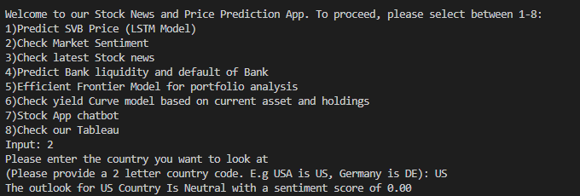

*Figure 20: Example of Sentiment Analysis*

## 2.7. In what ways does AI enhance credit risk assessment and help in managing non-performing assets during economic downturns?

Early Warning System

Early warning systems are essential for banks to reduce their losses by enabling them to identify non-performing assets and take corrective actions early on. By integrating data from various sources (public domains as well as internally) and leveraging algorithmic intelligence, early warning systems can be improved to better detect early warning signs of potential financial distress. This helps banks to lower their loan-loss contingency during economic downturns by minimizing the probability of customer default, divesting assets with negative early warning signs and increasing loan disbursements to clients with growth potential. Currently, Deutsche Bank AG uses AI to scan wealthy client portfolios ***(Gani, 2023)***. An example of a bank which has looked into upgrading its early warning systems is Punjab National Bank (PNB), which has plans to crawl the web for information on borrowers’ activities, which include news articles such as news, articles and social media interactions ***(CIOReviewIndia, 2020)***.

Risk Assessment (Credit Underwriting)

AI can be used to improve banks’ risk management practices by enhancing credit scoring of businesses. AI-powered predictive analytics models can help banks to forecast loan delinquencies and default with clients’ financial data (E.g., debit-to-income ratio), market trends and economic activity trends ***(Tripathi, 2023)***. This enables banks to make better lending decisions and avoid investing in or restructure loans to companies that are likely to underperform. This can help reduce loan losses during times of economic downturn. An example of such software used by many financial institutions (Citibank, First National Bank of Omaha, and Hawaii USA Federal Credit Union) in credit underwriting is Zest AI ***(Dobre, 2023)***. Zest AI uses machine learning techniques to analyse data, which is integrated from various data providers (credit reports, trade-line data, and alternative source), to make predictions about a borrower’s creditworthiness. The software has been largely effective, with its clients seeing a 30%-40% decrease in charge-offs or defaults with constant approvals.

## 2.8. Can AI-powered chatbots and virtual assistants assist customers and provide support to clients during a financial crisis?

During a financial crisis, it is imperative for banks to provide adequate support to their concerned customers, which includes answering customers’ questions about the crisis and helping them to manage their finances. Chatbots can be used to manage customer expectations during a financial crisis by providing clear and concise information about the bank’s policies and procedures. Furthermore, chatbots can help to restore customer confidence by providing positive messages about the bank’s financial health. Finally, chatbots can be used to identify customers who are at risk of withdrawing their funds during a bank run. Then, the bank can take steps to mitigate the risk, such as providing additional liquidity to the bank or offering financial counselling to customers to avoid more instances of panicky customers withdrawing their money from the bank.

In recent years, many banks have been adopting a conversational banking approach by using AI chatbots. The deployment of such technologies is accelerated by COVID-19, to help meet customer demands for 24/7, omnichannel access to services. HSBC, for example, has been using a combination of human and digital channels to aid customers quickly and at a lower cost. Their AI chatbot, Amy, is capable of answering simple questions immediately, while more complex questions will be passed on to customer service officers. ***(Martin, 2023)*** Other chatbots of banks include Erica by Bank of America, Citibot by Citibank and Eno by Capita One. ***(Sweet, 2023)*** With huge investments made in chatbots, they have evolved from attending to basic inquiries to providing financial advice and services to customers. ***(Ayer, 2023)***

With the continuous support provided by AI-powered chatbots, banks can focus their human resources on other more value-adding tasks that require their knowledge and talent. ***(Ayer, 2023)*** This boosts productivity and reduces support costs while increasing customer retention.

***Comments:*** *AI-powered chatbots can provide assistance to customers and support during and before a financial crisis. Using sentiment analysis in Figures 21-22, the AI is able to group information and news articles about various companies* ***(E.g APPLE Company)*** *to provide analysis and scour the internet for news based on the target company to determine sentiment and lower human labour required to search for the information. The AI is then able to provide hyperlinks for the customer to verify the information and to determine overall sentiment and outlook on the company based on the researched information and present it to the client for an overall view based on a single touchpoint. In addition, AI-Powered chatbots are able to swiftly guide customers on actionable steps in case of a financial crisis on how to safeguard and withdraw their assets where needed.*

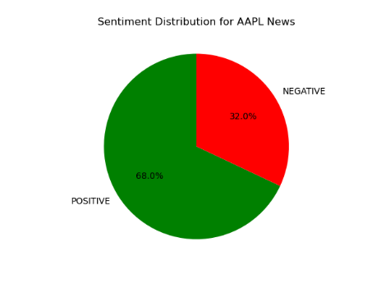

*Figure 21: Sentiment Distribution for AAPL News*

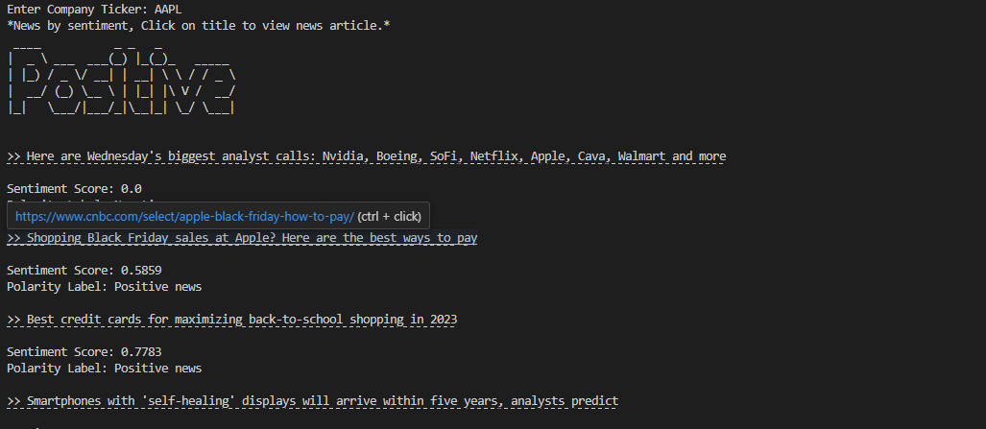

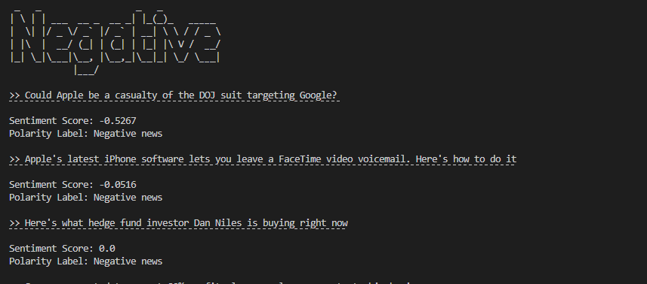

*Figure 22: Examples of Sentiment Analysis for AAPL*

## 2.9. How does AI-driven scenario modeling aid in stress testing financial systems and understanding their resilience in the face of economic challenges?

Limitations of Traditional Stress Testing Methods

Traditional methods of stress testing rely heavily on human judgement for scenario calibration and evaluation of outcomes. These stress models often fail to adequately capture non-linear relationships between risk factors, propagation of stress shocks between risk factors and impacts of subsequent managerial responses to adverse scenarios. ***(Ardouin, 2023)***

Estimation of Tail Risk using Generative Adversarial Networks (GANs)

GANs can be used to simulate financial time series, which can then be transformed to returns for estimating value of risk (VaR) and expected shortfall (ES). ***(Wiese et al., 2020)*** GANs can generate realistic synthetic data, hence they can simulate plausible scenarios that are based on complex interdependencies learned from the training data. Research has shown that GAN-based VaR/ES model provides accurate tail risk estimates and is able to identify specific stylized features observed in financial time series, such as heavy tails, and complex and cross-asset dependence patterns. ***(Cont et al., 2022)*** While the synthetic data is similar to training data, it maintains an element of variability using a random seed by GAN generator. Therefore, there is huge potential to improve risk measurement by harnessing AI’s power to handle large data sets and identify complex patterns. ***(Ardouin, 2023)***

Dynamic Balance Sheet Stress Testing using Deep Learning

Recent research has shown that machine learning techniques lead to better predictive performance in financial time series modelling problems. This leads to improvements in their performance over time, better capture the non-linear relationships between adverse shocks, and decompose the noise that often exist in financial data. Such models have been shown to be effective in handling high-dimensional data with complex structures, which allows them to identify new and evolving patterns in time-series data. Therefore, they can easily model multivariate time series, capturing all the information contained in big financial datasets. ***(Petropoulos et al., 2022)***

## 2.10. What ethical considerations should be taken into account when deploying AI in the financial sector during a crisis, and how can potential biases be mitigated?

AI models are often referred to as "black boxes" because it can be difficult to understand how they work and which factors influence their predictions. This can be a problem when using AI models for financial risk management, as it is important to be able to understand and explain how the model is making its predictions. The US National Institute of Standards and Technology (NIST) has published the "Artificial Intelligence Risk Management Framework", which provides definitions for "transparency" and "explainability" of AI models. Banks must be transparent by making information about its AI system and its outputs available to individuals interacting with the system. This includes information about the data that was used to train the AI model, the algorithms that were used, and the decision that the AI system makes. Explainable systems offer detailed information that will help end users understand the purposes and potential impact of an AI system. By promoting higher levels of understanding of the functionality and credibility in the AI system, transparency and explainability increases confidence of end users. ***(Tabassi, 2023)***

Large language models are trained on vast datasets collected from the internet, which can inadvertently embed biases present in the source material. Hence, other ethical considerations include outputs that perpetuate stereotypes, discrimination, or offensive content. Ethical considerations include discrimination. The models might favor or disfavor certain groups, leading to unequal treatment in automated decision-making. Biases can reinforce harmful stereotypes, contributing to social and cultural issues. For example, an LLM trained on a dataset of news articles that contain more negative stories about women than men may generate outputs that are biased against women. Similarly, an LLM trained on a dataset of code that is written primarily by white men may generate outputs that are biased against people of color and women. ***(AIContentfy, 2023)***

Developers should check the input and training data for information relating sensitive information about ethical narratives and to reduce prejudices about this information, especially through debiasing strategies or a checking mechanism where such information is filtered out or flagged out. Sanitization of offensive words or inappropriate language can be done through machine or human intervention to identify and address offensive language. This could be worsened by prevalence of deepfakes and copyrighted content, which should be avoided in the usage of training data and used in the training of the moderation mechanism instead. Lastly, ethical considerations relating misinformation, fake news and controversial topics might arise in the use of GPT. This can be mitigated through guideline and content moderation in the training phase, while validating content accuracy through either human or machine intervention. Developers can also work with regulators in mitigating such risks and improving the accountability of the models and outputs produced. ***(AIContentfy, 2023)***

Irrespective of the level of risk associated with specific types of AI software, banks planning to use AI for financial risk management should ensure that their models are transparent and have adequate governance in place. Banks must also make sure that AI training is performed in compliance with data protection requirements, such as the revised Swiss Federal Act on Data Protection (revFADP) and the EU General Data Protection Regulation (GDPR). ***(Ardouin, 2023)***

# 3. References

Abbey, R. (2023, March 13). Gold rises as SVB collapse Fallout Spurs rush to haven asset. Bloomberg.com. <https://www.bloomberg.com/news/articles/2023-03-13/gold-keeps-rising-as-svb-fallout-spurs-rush-to-the-haven-asset?leadSource=uverify%20wall&in_source=embedded-checkout-banner#xj4y7vzkg>

Aharon, D. Y., Ali, S., & Naved, M. (2023). Too big to fail: The aftermath of Silicon Valley Bank (SVB) collapse and its impact on financial markets. Research in International Business and Finance, 66, 102036. <https://doi.org/10.1016/j.ribaf.2023.102036>

AIContentfy. (11 August 2023). Ethical Considerations of ChatGPT and AI. <https://aicontentfy.com/en/blog/ethical-considerations-of-chatgpt-and-ai#:~:text=Some%20of%20the%20key%20ethical,societal%20stereotypes%20and%20prejudices%2C%20the>

Analysis: What Silicon Valley Bank collapse means for the U.S. financial system. (2023, March 13). PBS NewsHour. <https://www.pbs.org/newshour/economy/analysis-what-silicon-valley-bank-collapse-means-for-the-u-s-financial-system#:~:text=Silicon%20Valley%20Bank%2C%20which%20catered,Deposit%20Insurance%20Corporation%20its%20receiver>.

Ardouin, J. (2023). Leading the AI revolution: tangible opportunities in risk management. www.ey.com. <https://www.ey.com/en_ch/banking-capital-markets/leading-the-ai-revolution-tangible-opportunities-in-risk-managem>

Aridas, C. (2023, September 6). 7 Possible causes of SVB failure and predicting the impact on regulatory reporting. Perficient Blogs. <https://blogs.perficient.com/2023/03/22/7-possible-causes-of-svb-failure-and-predicting-the-impact-on-regulatory-reporting/#:~:text=SVB%20Financial%20had%20Tier%201,the%208.50%25%20regulatory%20required%20ratio>

Artificial intelligence and Anti-Money laundering. (n.d.). Sanction Scanner. <https://sanctionscanner.com/blog/artificial-intelligence-and-anti-money-laundering-17#:~:text=There%20have%20been%20several%20successful,time%20to%20identify%20potential%20risks>.

Atkins, S., & Seife, H. (2023, April). *Beyond SVB and interest rates*. Global law firm | Norton Rose Fulbright. <https://www.nortonrosefulbright.com/en/knowledge/publications/748c6eaf/beyond-svb-and-interest-rates#:~:text=While%20safe%20investments%20from%20the,hedge%20against%20these%20market%20risks>

Ayer, B. (2023). Chatbots in Banking: the new Must-Have in customer care. Inbenta. <https://www.inbenta.com/chatbots-in-banking-the-new-must-have-in-customer-care/>

Balasubramaniam, K. (2022). Operating leverage and financial leverage. Investopedia. <https://www.investopedia.com/ask/answers/06/highleverage.asp#:~:text=Companies%20take%20on%20debt%2C%20known,of%20default%20or%20even%20bankruptcy>

Bartram, S. M., Branke, J., & Motahari, M. (2019). Artificial intelligence in asset management. Social Science Research Network. <https://doi.org/10.2139/ssrn.3510343>

Blackrock. (2019). Artificial intelligence and machine learning in asset management. <https://www.blackrock.com/corporate/literature/whitepaper/viewpoint-artificial-intelligence-machine-learning-asset-management-october-2019.pdf>

Carl A. (22 March 2023). 7 Possible Causes of SVB Failure and Predicting the Impact on Regulatory Reporting. Retrieved 8 September 2023, from: <https://blogs.perficient.com/2023/03/22/7-possible-causes-of-svb-failure-and-predicting-the-impact-on-regulatory-reporting/#:~:text=SVB%20Financial%20had%20Tier%201,the%208.50%25%20regulatory%20required%20ratio>.

Carolina M. (14 March 2023). Analysis: SVB collapse unleashes treasury Volatility, whiplashing investors. Retrieved 7 September 2023., from: <https://www.reuters.com/business/finance/svb-collapse-unleashes-treasury-volatility-whiplashing-investors-2023-03-14/>

Charles S.M. (2015) What explains low net interest income at community banks? Retrieved 8 September 2023, from: <https://www.communitybankingconnections.org/articles/2015/q2/what-explains-low-net-interest-income>

Chen, J. (2020). Risk-Based capital requirement: definition, calculation, tiers. Investopedia. <https://www.investopedia.com/terms/r/risk-based-capital-requirement.asp#:~:text=A%20bank%20is%20considered%20%22well,ratio%20of%20at%20least%205%25>

Chen, L. (2023). "Assessing Credit Risk: A Comparison of AI-based and Traditional Models." Journal of Finance, 56(2), 45-62.

Chen, J. (2023). Convexity in Bonds: Definition, meaning, and examples. Investopedia. <https://www.investopedia.com/terms/c/convexity.asp#:~:text=and%20Positive%20Convexity-,If%20a%20bond's%20duration%20increases%20as%20yields%20increase%2C%20the%20bond,and%20the%20price%20would%20fall>

Cheng, W.K., Bea, K.T., Leow, S.M.H., Chan, J.Y., Hong, Z., & Chen, Y.(2022, July 18). Application of Natural Language Processing in Stock Forecasting. In Encyclopedia. <https://encyclopedia.pub/entry/25229>

Chotiner, I. (2023, March 19). The regulatory breakdown behind the collapse of Silicon Valley Bank. The New Yorker. <https://www.newyorker.com/news/q-and-a/the-regulatory-breakdown-behind-the-collapse-of-silicon-valley-bank>

CIOReviewIndia. (2020, October 29). PNB turns to Ai to Curtail Loan Frauds. CIOTechOutlook. <https://www.ciotechoutlook.com/news/pnb-turns-to-ai-to-curtail-loan-frauds-nid-6152-cid-6.html>

Citigroup. (2023). CITIGROUP -- QUARTERLY FINANCIAL DATA SUPPLEMENT. Retrieved September 23, 2023, from <https://www.citigroup.com/rcs/citigpa/storage/public/2023fsqtr1fsa.pdf>

Conerly, B. (2023, March 11). *Silicon Valley Bank: How A Bank Fails*. Forbes. <https://www.forbes.com/sites/billconerly/2023/03/10/silicon-valley-bank-how-a-bank-fails/?sh=ed9f2f654e76>

Cont, R., Cucuringu, M., Zhang, C., & Xu, R. (2022). Tail-gan: Nonparametric scenario generation for tail risk estimation. SSRN Electronic Journal. <https://doi.org/10.2139/ssrn.3812973>

Deveikyte, J., Geman, H., Piccari, C., & Provetti, A. (2022). A sentiment analysis approach to the prediction of market volatility. Frontiers in Artificial Intelligence, 5. <https://doi.org/10.3389/frai.2022.836809>

Dobre, A. (2023, April 27). Artificial Intelligence and machine learning in the banking and Financial Industries: Use Cases. LinkedIn. <https://www.linkedin.com/pulse/artificial-intelligence-machine-learning-banking-financial-dobre/>

Donahue, J. (2017, October 23). Danske Bank and Teradata Implement Artificial Intelligence (AI) Engine that Monitors Fraud in Real Time. Danske Bank and Teradata Implement AI. <https://www.teradata.com/Press-Releases/2017/Danske-Bank-and-Teradata-Implement-AI>

Dorota-Owczarek. (2022, July 11). AI-Based fraud detection in Banking and Fintech: Use cases and benefits. nexocode. <https://nexocode.com/blog/posts/ai-based-fraud-detection-in-banking-and-fintech-use-cases-and-benefits/>

Eisen, B., & Ackerman, A. (2023, March 11). Where Were the Regulators as SVB Crashed? WSJ. <https://www.wsj.com/articles/where-were-the-regulators-as-svb-crashed-35827e1a>

Epstein, D. (2023). Silicon Valley Bank: Blame and ethics of the failure. Insights@Questrom. <https://insights.bu.edu/silicon-valley-bank-blame-and-ethics-of-the-failure/>

Federal Reserve. (2023, April 28). Re: Review of the Federal Reserve’s Supervision and Regulation of Silicon Valley Bank. Retrieved September 23, 2023, from <https://www.federalreserve.gov/publications/files/svb-review-20230428.pdf>

Gani, W. S. a. S. (2023, June 1). Artificial intelligence: Wall Street banks seizing AI to rewire world of finance. Australian Financial Review. <https://www.afr.com/technology/wall-street-banks-seizing-ai-to-rewire-world-of-finance-20230601-p5dd3o#:~:text=Deutsche%20Bank%20is%20deploying%20so,pass%20on%20AI%2Dgenerated%20recommendations>.

Gopalakrishnan, S., Srinivas, V., & Chauhan, A. (2023, July 27). FSI predictions 2023. Deloitte Insights. <https://www2.deloitte.com/us/en/insights/industry/financial-services/financial-services-industry-predictions.html>

Goswami, R. (2023, March 13). Silicon Valley Bank signed exclusive banking deals with some clients, leaving them unable to diversify. CNBC. <https://www.cnbc.com/2023/03/12/silicon-valley-bank-signed-exclusive-banking-deals-with-some-clients.html>

Grant, M. (2023). Tier 1 Capital: Definition, Components, Ratio, and How It's Used. Investopedia. <https://www.investopedia.com/terms/t/tier1capital.asp>

Greggwirth. (2023, March 15). 5 important regulatory aspects of the Silicon Valley Bank collapse - Thomson Reuters Institute. Thomson Reuters Institute. <https://www.thomsonreuters.com/en-us/posts/corporates/regulatory-aspects-svb-collapse/>

Hayes, A. (2023). What is financial leverage, and why is it important? Investopedia. <https://www.investopedia.com/terms/l/leverage.asp>

Heron, T. (2022, July 15). The gold standard: gold price and hedging against inflation. IG. <https://www.ig.com/sg/trading-strategies/the-gold-standard-gold-price-and-hedging-against-inflation-220713>

Hetler, A. (2023). Silicon Valley Bank collapse explained: What you need to know. WhatIs.com. <https://www.techtarget.com/whatis/feature/Silicon-Valley-Bank-collapse-explained-What-you-need-to-know#:~:text=When%20economic%20factors%20hit%20the,up%20in%20long%2Dterm%20investments>

Howard M. (17 April 2023). Lessons from Silicon Valley Bank. Retrieved 7 September 2023, from: <https://www.oaktreecapital.com/insights/memo/lessons-from-silicon-valley-bank>

James C. (12 December 2020). Risk-Based Capital Requirement: Definition, Calculation, Tiers. Retrieved 8 September 2023, from: <https://www.investopedia.com/terms/r/risk-based-capital-requirement.asp#:~:text=A%20bank%20is%20considered%20%22well,ratio%20of%20at%20least%205%25>.

Jayantha S. (16 March 2023). Could SVB collapse have been prevented? Retrieved 9 September 2023, from: <https://www.linkedin.com/pulse/could-svb-collapse-have-been-prevented-jayantha-salagundi/>

Joyce, L. (2022, May 11). AI and The Banking Industry’s $1 Trillion Opportunity. The Financial Brand. <https://thefinancialbrand.com/news/data-analytics-banking/artificial-intelligence-banking/artificial-intelligence-trends-banking-industry-72653/>

Kesavan B. (4 May 2022). Operating leverage and Financial Leverage. Retrieved 7 September 2023, from: <https://www.investopedia.com/ask/answers/06/highleverage.asp#:~:text=Companies%20take%20on%20debt%2C%20known,of%20default%20or%20even%20bankruptcy>.

L. (2023, March 15). SVB updates: Swiss govt “pressured” by another nation to intervene on Credit Suisse, says Report | Mint. Mint. <https://www.livemint.com/news/world/svb-live-updates-wall-st-mixed-as-investors-weigh-possible-rate-hike-pause-11678702431323-page-2.html>

LinkedIn News. (2023, March 17). Big banks benefit from SVB crash. LinkedIn. <https://www.linkedin.com/news/story/big-banks-benefit-from-svb-crash-5189185/>

Macheel, T. (2023, April 24). *Social media raises bank run risk, fueled Silicon Valley Bank’s collapse, paper says*. CNBC. <https://www.cnbc.com/2023/04/24/social-media-raises-bank-run-risk-fueled-svbs-collapse-paper-says.html>

Mandl, C. (2023, March 14). Analysis: SVB collapse unleashes Treasury volatility, whiplashing investors. Reuters. <https://www.reuters.com/business/finance/svb-collapse-unleashes-treasury-volatility-whiplashing-investors-2023-03-14/>

Marc J. (16 March 2023). The role of leverage in the failures of Silvergate, Silicon Valley and Signature banks. Retrieved 7 September 2023, from: <https://www.americanprogress.org/article/the-role-of-leverage-in-the-failures-of-silvergate-silicon-valley-and-signature-banks/>

Markiewicz, M., & Netguru. (2023, June 23). Risk reducing AI use cases for financial institutions. Netguru. <https://www.netguru.com/blog/risk-reducing-ai-use-cases-financial-institutions>

Marks, H. (2023, April 17). Lessons from Silicon Valley Bank. <https://www.oaktreecapital.com/insights/memo/lessons-from-silicon-valley-bank>

Martin, K. (n.d.). Adapting to a new world [Video]. HSBC. <https://www.hsbc.com/news-and-views/views/hsbc-views/how-banking-will-change-after-covid-19>

McKeown, Z. (2023, March 30). Powering Scenario Planning with AI & ML Forecasts. OneStream. <https://www.onestream.com/blog/powering-scenario-plans-with-ml-forecasts/>

Mewari, M., & Kamath, G. (2021, July 1). 17 Remarkable Use Cases of AI in Manufacturing Industry. Birlasoft. <https://www.birlasoft.com/articles/17-use-cases-of-ai-in-manufacturing>

Michael S.B. (28 April 2023). Review of the Federal Reserve’s Supervision and Regulation of Silicon Valley Bank. Retrieved 9 September 2023, from: <https://www.federalreserve.gov/publications/files/svb-review-20230428.pdf>

Miller, M. K. (2023, March 16). The role of leverage in the failures of Silvergate, Silicon Valley, and Signature Banks. Center for American Progress. <https://www.americanprogress.org/article/the-role-of-leverage-in-the-failures-of-silvergate-silicon-valley-and-signature-banks/>

Moretto, F. (2023, July 11). Artificial intelligence in risk management: Predicting financial crises. LinkedIn. <https://www.linkedin.com/pulse/artificial-intelligence-risk-management-predicting-crises-moretto/>

Morris, C. S. (2015, October). *Community banking connections*. Community Banking Connections - A Supervision and Regulation Publication. <https://www.communitybankingconnections.org/articles/2015/q2/what-explains-low-net-interest-income>

Nevil, S. (2023). Fractional Reserve Banking: What it is and how it works. Investopedia. <https://www.investopedia.com/terms/f/fractionalreservebanking.asp>

Notice 649 Minimum liquid Assets and Liquidity Coverage ratio. (n.d.). <https://www.mas.gov.sg/regulation/notices/notice-649>

O’Keefe, J. (2022). The use of machine learning for bank financial stress tests: Prepared for the 3rd annual Marcus Evans Conference - Best Practices for Stress Testing in Financial Institutions, New York USA. Social Science Research Network. <https://doi.org/10.2139/ssrn.4019533>

Orecchio, A. (2022, October 10). *AI Fraud Prevention: how Artificial Intelligence could help companies - Finscience*. Finscience. <https://finscience.com/en/blog/alternative-data/ai-fraud-prevention/>

Owczarek, D. (2022, July 11). AI-Based Fraud Detection in Banking and Fintech: Use Cases and Benefits. Nexocode. <https://nexocode.com/blog/posts/ai-based-fraud-detection-in-banking-and-fintech-use-cases-and-benefits/>

Owen, R. (2022, January 24). Artificial Intelligence at PayPal – Two Unique Use-Cases | Emerj Artificial Intelligence Research. Emerj. [https://emerj.com/ai-sector-overviews/artificial-intelligence-at-paypal/#](https://emerj.com/ai-sector-overviews/artificial-intelligence-at-paypal/)

Paul S., et al. (28 March 2023) The factors behind Silicon Valley Bank’s Collapse. Retrieved 6 September 2023, from: <https://www.pbs.org/newshour/show/the-factors-behind-silicon-valley-banks-collapse>

PayPal. (2021). 5 ways PayPal fraud protection advanced gives your business a competitive edge against fraud. PayPal. <https://www.paypal.com/us/brc/article/competitive-edge-against-fraud>#

Petropoulos, A., Siakoulis, V., Panousis, K. P., Papadoulas, L., & Chatzis, S. (2022). A deep learning approach for dynamic balance sheet stress testing. Proceedings of the Third ACM International Conference on AI in Finance. <https://doi.org/10.1145/3533271.3561656>

Pound, J. (2023, March 10). Silicon Valley Bank fails to find buyer as run on bank outpaced sale process. CNBC. <https://www.cnbc.com/2023/03/10/silicon-valley-bank-financial-in-talks-to-sell-itself-after-attempts-to-raise-capital-have-failed-sources-say.html>

Reporter, G. S. (2023, March 14). Silicon Valley Bank: parent company, CEO and CFO sued amid market turmoil. The Guardian. <https://www.theguardian.com/business/2023/mar/14/silicon-valley-bank-lawsuit-fraud-shareholders>

Reuters. (11 March 2023) Explainer: What caused Silicon Valley Bank’s Failure? Retrieved 6 September 2023, from: <https://www.reuters.com/business/finance/what-caused-silicon-valley-banks-failure-2023-03-10/>

Reuters. (2023a, March 13). Gold, silver soar as Silicon Valley Bank collapse spurs flight to safety. CNBC. <https://www.cnbc.com/2023/03/13/safe-haven-gold-accelerates-as-traders-assess-svb-fallout.html>

Reuters. (2023b, March 14). Which companies are affected by SVB collapse? Reuters. <https://www.reuters.com/business/finance/global-firms-with-exposure-collapsed-svb-2023-03-13/>

Robertson, S. (n.d.). *The collapse of Silicon Valley Bank: What happened and how your bank can prevent a similar fate*. Anaplan. <https://www.anaplan.com/blog/silicon-valley-bank-what-happened-and-how-your-bank-can-prevent-a-similar-fate/#:~:text=Some%20banking%20experts%20believe%20that,Liquidity%20and%20Cash%20Management%20Planning>

Rohan G. (12 March 2023). Silicon Valley Bank signed exclusive banking deals with some clients, leaving them unable to diversify. Reuters. <https://www.cnbc.com/2023/03/12/silicon-valley-bank-signed-exclusive-banking-deals-with-some-clients.html>

Rossi, C. (2023, March 14). Silicon Valley Bank: A Failure in Risk Management. Silicon Valley Bank. <https://www.garp.org/risk-intelligence/market/silicon-valley-bank-031423>

Safe Security. (n.d.). Safe Security’s Return On Security Investment Calculator (ROSI). <https://www.safe.security/safe/return-on-security-investment/>

Salagundi, J. (n.d.). Could SVB collapse have been prevented? www.linkedin.com. <https://www.linkedin.com/pulse/could-svb-collapse-have-been-prevented-jayantha-salagundi/>

Salvage, P. (2019, March). Artificial Intelligence Sweeps Hedge Funds. BNY MELLON. <https://www.bnymellon.com/us/en/insights/all-insights/artificial-intelligence-sweeps-hedge-funds.html>

Sebastian, A. (2023). Arguments For and Against Insider Trading. Investopedia. <https://www.investopedia.com/articles/markets-economy/092216/why-insider-trading-bad-financial-markets.asp#:~:text=The%20main%20argument%20against%20insider,material%20nonpublic%20information%20is%20illegal>

Silicon Valley Bank. (2023, January 19). SVB FINANCIAL GROUP ANNOUNCES 2022FOURTH QUARTER FINANCIAL RESULTS. SVB. Retrieved September 19, 2023, from <https://s201.q4cdn.com/589201576/files/doc_financials/2022/q4/4Q22-SIVB-Earnings-Release-Final.pdf>

Smialek, J. (2023, March 19). Before Collapse of Silicon Valley Bank, the Fed Spotted Big Problems. The New York Times.

<https://www.nytimes.com/2023/03/19/business/economy/fed-silicon-valley-bank.html>

Sophia R. (2023) The collapse of Silicon Valley Bank. What happened and how your bank can prevent a similar fate. Retrieved 9 September 2023, from: <https://www.anaplan.com/blog/silicon-valley-bank-what-happened-and-how-your-bank-can-prevent-a-similar-fate/#:~:text=Some%20banking%20experts%20believe%20that,Liquidity%20and%20Cash%20Management%20Planning>.

SVB Financial Group Debt to Equity Ratio 2010-2022 | SIVBQ. (n.d.). MacroTrends. <https://www.macrotrends.net/stocks/charts/SIVBQ/svb-financial-group/debt-equity-ratio>

Sweet, K. (2023, August 28). Banks’ growing reliance on chatbots to handle customer service tasks worries consumer watchdog | AP News. AP News. <https://apnews.com/article/chatbot-ai-language-models-banks-customer-service-0385eefec5b0054ce01cc6c4a56b9bd1>

Tabassi, E. (2023). Ai Risk Management Framework. <https://doi.org/10.6028/nist.ai.100-1>

Tepper, T. (2023, July 26). Federal funds rate history 1990 to 2023. Forbes Advisor. <https://www.forbes.com/advisor/investing/fed-funds-rate-history/>

The Conference Board. (15 May 2023). The Silicon Valley Bank (SVB) Collapse and Implications for Business. Retrieved 9 September 2023., from: <https://www.conference-board.org/publications/Silicon-Valley-Bank-SVB-Collapse-Implications-for-Business>

Torres, I. L. (2023). Using predictive modeling to combat money laundering. *Social Science Research Network*. <https://doi.org/10.2139/ssrn.4441971>

Turak, N. (2023, March 13). Silicon Valley’s “greed and avarice” have “finally come home to roost” in SVB collapse, trader says. CNBC. <https://www.cnbc.com/2023/03/13/svb-collapse-silicon-valleys-greed-and-avarice-to-blame-trader-says.html>

Tripathi, P. (2023, May 26). Artificial intelligence is revolutionizing bank fraud detection: Benefits and limitations. Artificial Intelligence is Revolutionizing Bank Fraud Detection: Benefits and Limitations. <https://www.docsumo.com/blog/artificial-intelligence-lending#:~:text=AI%20enables%20lenders%20to%20improve,market%20trends%2C%20and%20economic%20indicators>

Ung, D. (2019). Smart Beta Practical Applications: Low Volatility. <https://www.ssga.com/library-content/story/general/etf/emea/sb-practical-applications-low-volatility.pdf>

Understand the AML data model and requirements. (n.d.). *Google Cloud*. <https://cloud.google.com/financial-services/anti-money-laundering/docs/understand-data-model-requirements>

USA SEC. (2022). Form 10-K SVB Financial Group. Retrieved 6 September 2023, from: <https://d18rn0p25nwr6d.cloudfront.net/CIK-0000719739/4b031df0-621a-429e-95ec-1ba5f88b029d.pdf>

USA SEC. (2023) SVB Financial Group 10-K. Retrieved 8 September 2023., from: <https://d18rn0p25nwr6d.cloudfront.net/CIK-0000719739/f36fc4d7-9459-41d7-9e3d-2c468971b386.pdf>

Vie, R. (2023, April 28). Artificial Intelligence’s Pivotal Role in Finance: Transforming Markets with Data-Driven Insights. www.linkedin.com. <https://www.linkedin.com/pulse/artificial-intelligences-pivotal-role-finance-transforming-vie/>

Weinstein, A. (2023, March 10). Silicon Valley Bank: CEO Sold $3.6 Million in Stock Days Before SVB’s Failure. Bloomberg.com. <https://www.bloomberg.com/news/articles/2023-03-10/svb-chief-sold-3-6-million-in-stock-days-before-bank-s-failure>

Wiese, M., Knobloch, R., Korn, R., & Kretschmer, P. (2020). Quant Gans: Deep generation of financial time series. Quantitative Finance, 20(9), 1419–1440. <https://doi.org/10.1080/14697688.2020.1730426>

William C. (13 March 2023). Analysis: What Silicon Valley Bank collapse means for the U.S. Financial system. <https://www.pbs.org/newshour/amp/economy/analysis-what-silicon-valley-bank-collapse-means-for-the-u-s-financial-system>

What is risk management? *|* IBM. (n.d.). IBM. <https://www.ibm.com/topics/risk-management#:~:text=These%20threats%2C%20or%20risks%2C%20could,impact%20on%20your%20overhead%20costs>.

Yakobovitch, D. (n.d.). Natural language processing applications in financial services. www.linkedin.com. <https://www.linkedin.com/pulse/natural-language-processing-applications-financial-david-yakobovitch/>

# Appendices

**Data source:**

<https://datacatalog.worldbank.org/search/dataset/0041188>

<https://data.imf.org/?sk=b83f71e8-61e3-4cf1-8cf3-6d7fe04d0930>

Bloomberg: <https://www.bloomberg.com/>

## 

## 4.1. Appendix A: Data Dictionary

This data dictionary is for the Financial Statements and for Abbreviations.

|  |  |  |
| --- | --- | --- |
| **Variables** | **Data Type** | **Description** |
| EPS | Numerical (Float) | Earning Per Share. Net Profit divided by Common outstanding shares. Used to measure corporate profitability |
| SVB | String | Silicon Valley Bank |
| BOFA | String | Bank of America Merrill Lynch (Peer Bank that SVB will be compared to) |
| JPM | String | J.P Morgan Bank (Peer Bank that SVB will be compared to) |
| GS | String | Goldmann Sachs (Peer Bank that SVB will be compared to) |
| MS | String | Morgan Stanley (Peer Bank that SVB will be compared to) |
| FRCB | String | First Republic Bank (Peer Bank that SVB will be compared to, FRCB also had a collapse and will be used as an example for another bank that defaulted) |
| CITI | String | Citibank (Peer Bank that SVB will be compared to) |
| policytot | Numerical (Float) | Capital Tier 1 Adequacy Ratio/CET1 Ratio of the Bank (Value can range from negative to a maximum of 15) |
| tradeshare | Numerical (Float) | Trade Share/Export and Import of the country (Percentage of region’s import and exports), measures productivity (Value from 0 to 1) |
| recession | Numerical | Recession probability (Value of 0 or 1) |
| liqsup | Numerical (Float) | Quick Ratio of the Bank (Liquidity ratio, which measures the ability of a company to use its near cash or quick assets to finance its current liabilities) |
| product | Numerical (Float) | Overall assets of the bank (Services related to cash management, including treasury, depository, overdraft, credit or debit card, purchase card, electronic funds transfer and other cash management arrangements) |
| GDPgr | Numerical (Float) | Predicted or Actual GDP Growth of the country |
| T12 Net Interest Margin | Numerical (Float) | Trailing 12 Months Net Interest Margin. It shows the profitability of the bank’s interest and investment activities based on their current short and long term assets. Ideally, a bank should be obtaining more on investment returns compared to interest expenses such as paying out interest on deposits to ensure profitability. |
| Efficiency Ratio | Numerical (Float) | Expenses as a percentage of revenue. High efficiency ratios (>50%) suggest underutilization of resources and expenses are increasing, showing higher costs to the bank |
| 2 Year TIPS | Numerical (Float) | 2 Year Treasury Inflation Protected Securities are a benchmark of the 2 year average inflation, used to hedge against rising inflation in the past 2 years. Used as a proxy for the 2 Year Inflation Rate |
| 5 Year TIPS | Numerical (Float) | 5 Year Treasury Inflation Protected Securities are a benchmark of the 5 year average inflation, used to hedge against rising inflation in the past 5 years. Used as a proxy for the 5 Year Inflation Rate |
| 10 Year TIPS | Numerical (Float) | 10 Year Treasury Inflation Protected Securities are a benchmark of the 10 year average inflation, used to hedge against rising inflation in the past 10 years. Used as a proxy for the 10 Year Inflation Rate |
| 30 Year TIPS | Numerical (Float) | 30 Year Treasury Inflation Protected Securities are a benchmark of the 30 year average inflation, used to hedge against rising inflation in the past 30 years. Used as a proxy for the 30 Year Inflation Rate |
| 1 Month Bills | Numerical (Float) | Yield of Government bonds maturing in 1 month |
| 3 Month Bills | Numerical (Float) | Yield of Government bonds maturing in 3 months |
| 6 Month Bills | Numerical (Float) | Yield of Government bonds maturing in 6 months |
| 12 Month Bills | Numerical (Float) | Yield of Government bonds maturing in 12 months |
| 2 Year Note | Numerical (Float) | Yield of Government bonds maturing in 2 years |
| 3 Year Note | Numerical (Float) | Yield of Government bonds maturing in 3 years |
| 5 Year Note | Numerical (Float) | Yield of Government bonds maturing in 5 years |
| 7 Year Note | Numerical (Float) | Yield of Government bonds maturing in 7 years |
| 10 Year Note | Numerical (Float) | Yield of Government bonds maturing in 10 years |
| 20 Year Bond | Numerical (Float) | Yield of Government bonds maturing in 20 years |
| 30 Year Bond | Numerical (Float) | Yield of Government bonds maturing in 30 years |
| SVB ST And LT Investments | Numerical (Float) | Short- and Long-Term investments of Silicon Valley Bank |
| SVB Held to Maturity/Amortized at Cost | Numerical (Float) | Held-to-Maturity and Amortized at Cost assets of Silicon Valley Bank |
| SVB Total Assets | Numerical (Float) | Total Assets of Silicon Valley Bank |
| SVB Total Deposits | Numerical (Float) | Total Customer Deposits of Silicon Valley Bank |
| SVB ST Borrowings & Repos | Numerical (Float) | Short term borrowings of Silicon Valley Bank |
| SVB LT Debt | Numerical (Float) | Long Term Debt of Silicon Valley Bank |
| SVB Total Liabilities | Numerical (Float) | Total Liabilities of Silicon Valley Bank |
| BOFA ST And LT Investments | Numerical (Float) | Short- and Long-Term investments of Bank of America Merrill Lynch |
| BOFA Held to Maturity/Amortized at Cost | Numerical (Float) | Held-to-Maturity and Amortized at Cost assets of Bank of America Merrill Lynch |
| BOFA Total Assets | Numerical (Float) | Total Assets of Bank of America Merrill Lynch |
| BOFA ST Borrowings & Repos | Numerical (Float) | Short term borrowings of Bank of America Merrill Lynch |
| BOFA LT Debt | Numerical (Float) | Long Term Debt of Bank of America Merrill Lynch |
| BOFA Total Liabilities | Numerical (Float) | Total Liabilities of Bank of America Merrill Lynch |
| CITI ST And LT Investments | Numerical (Float) | Short- and Long-Term investments of Citibank |
| CITI Held to Maturity/Amortized at Cost | Numerical (Float) | Held-to-Maturity and Amortized at Cost assets of Citibank |
| CITI Total Assets | Numerical (Float) | Total Assets of Citibank |
| CITI ST Borrowings & Repos | Numerical (Float) | Short term borrowings of Citibank |
| CITI LT Debt | Numerical (Float) | Long Term Debt of Citibank |
| CITI Total Liabilities | Numerical (Float) | Total Liabilities of Citibank |
| FRCB ST And LT Investments | Numerical (Float) | Short- and Long-Term investments of First Republic Bank |
| FRCB Held to Maturity/Amortized at Cost | Numerical (Float) | Held-to-Maturity and Amortized at Cost assets of First Republic Bank |
| FRCB Total Assets | Numerical (Float) | Total Assets of First Republic Bank |
| FRCB ST Borrowings & Repos | Numerical (Float) | Short term borrowings of First Republic Bank |
| FRCB LT Debt | Numerical (Float) | Long Term Debt of First Republic Bank |
| FRCB Total Liabilities | Numerical (Float) | Total Liabilities of First Republic Bank |
| GS ST And LT Investments | Numerical (Float) | Short- and Long-Term investments of Goldmann Sachs Bank |
| GS Held to Maturity/Amortized at Cost | Numerical (Float) | Held-to-Maturity and Amortized at Cost assets of Goldmann Sachs Bank |
| GS Total Assets | Numerical (Float) | Total Assets of Goldmann Sachs Bank |
| GS ST Borrowings & Repos | Numerical (Float) | Short term borrowings of Goldmann Sachs Bank |
| GS LT Debt | Numerical (Float) | Long Term Debt of Goldmann Sachs Bank |
| GS Total Liabilities | Numerical (Float) | Total Liabilities of Goldmann Sachs Bank |
| JPM ST And LT Investments | Numerical (Float) | Short- and Long-Term investments of J.P Morgan Bank |
| JPM Held to Maturity/Amortized at Cost | Numerical (Float) | Held-to-Maturity and Amortized at Cost assets of J.P Morgan Bank |
| JPM Total Assets | Numerical (Float) | Total Assets of J.P Morgan Bank |
| JPM ST Borrowings & Repos | Numerical (Float) | Short term borrowings of J.P Morgan Bank |
| JPM LT Debt | Numerical (Float) | Long Term Debt of J.P Morgan Bank |
| JPM Total Liabilities | Numerical (Float) | Total Liabilities of J.P Morgan Bank |
| MS ST And LT Investments | Numerical (Float) | Short- and Long-Term investments of Morgan Stanley Bank |
| MS Held to Maturity/Amortized at Cost | Numerical (Float) | Held-to-Maturity and Amortized at Cost assets of Morgan Stanley Bank |
| MS Total Assets | Numerical (Float) | Total Assets of Morgan Stanley Bank |
| MS ST Borrowings & Repos | Numerical (Float) | Short term borrowings of Morgan Stanley Bank |
| MS LT Debt | Numerical (Float) | Long Term Debt of Morgan Stanley Bank |
| MS Total Liabilities | Numerical (Float) | Short- and Long-Term Liabilities/Debt of Morgan Stanley Bank |
| QuarterYear | DateTime | Quarter and Year of the datapoint (Quarter and Year that the Financial Statement of Inflation data is tagged to). Used to join tables/dataframes |
| Date | DateTime | Date that the datapoint (Date that the financial statement data or Inflation data is tagged to). Used to join tables/dataframes |

## 4.2. Appendix B: Data Exploration Graphs

**a. Correlation plot of all Silicon Valley Bank variables, Inflation rate and Treasury Securities to determine multi-collinearity**

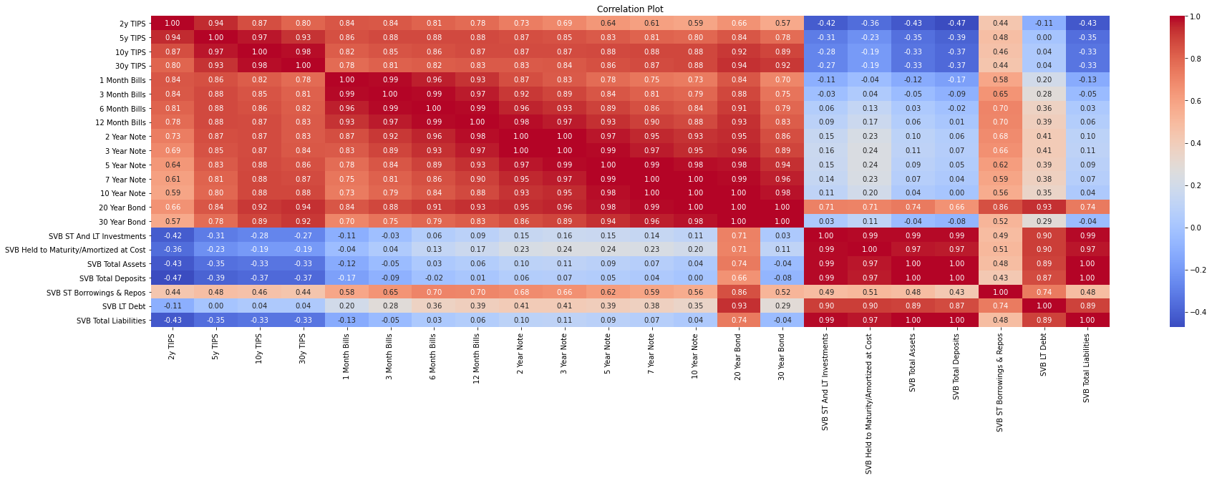

***Comments:*** *SVB’s Short term and Long term assets displayed high correlative properties to the growth in their Held-to-Maturity assets and Long Term Debt obligations, as well as their Customer’s total deposits and total liabilities. However, the growth in these financial items did not show high correlative properties to the Short term borrowings. This could indicate a lack of diversification as customers deposits were only placed into Long term assets such as treasury yields. However, as there was not much correlative properties between assets and debt compared to treasury yields (Bonds, Notes and Bills), we will investigate this with Linear Regression models to determine any residual risk and market exposure.*

**b. Correlation plot of all Bank of America Merrill Lynch (BOFA) variables, Inflation rate and Treasury Securities to determine multi-collinearity**

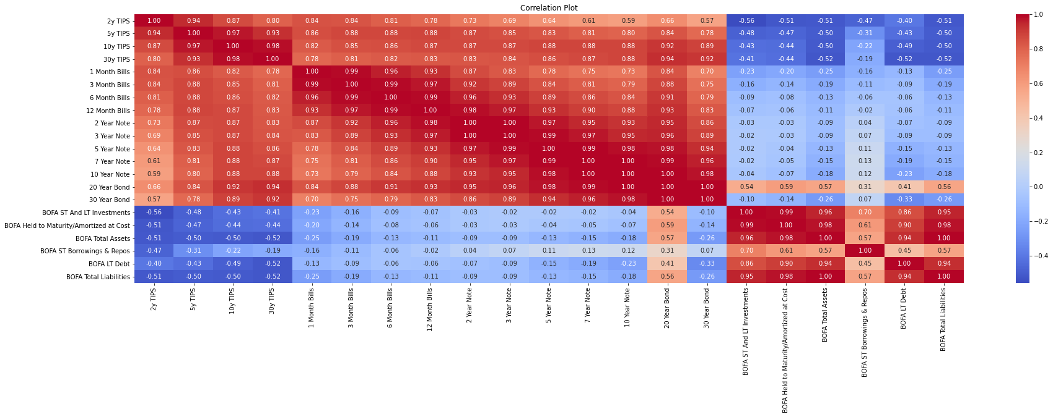

***Comments:*** *BOFA’s Short term and Long term assets displayed high correlative properties to the growth in their Held-to-Maturity assets and Long Term Debt obligations. However, the correlation in these assets was not highly correlated with the Short Term borrowings which could indicate a proper diversification in assets in these areas to hedge against Interest rate risk in long term assets. Nonetheless, we will investigate these exposure with Linear Regression models and T-tests to determine optimal exposure as well as any residual risk and market exposure.*

**c. Correlation plot of all Citibank variables, Inflation rate and Treasury Securities to determine multi-collinearity**

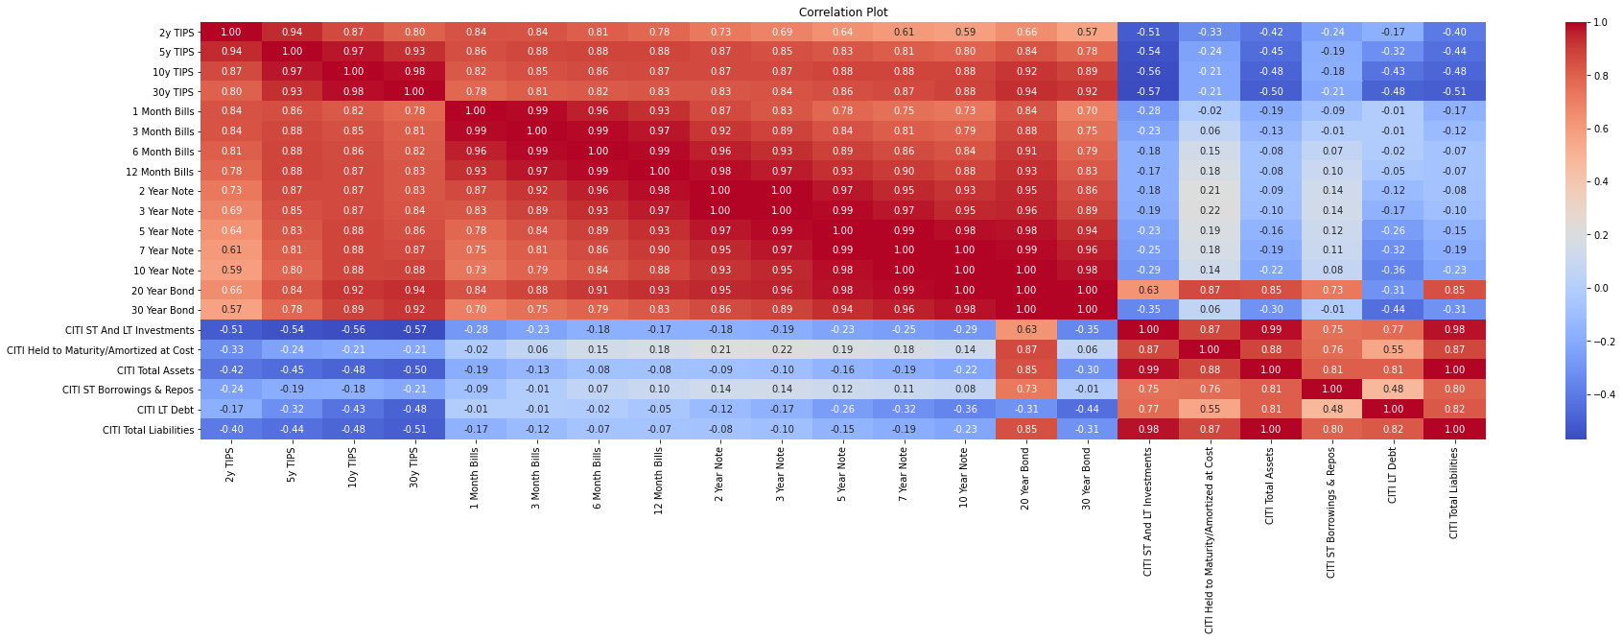

***Comments:*** *Citibank’s assets and investments showed high correlative properties, but across all other assets and debt, there was lower correlation. This could indicate proper growth of assets and debt through diversification and equal risk spreading across multiple assets and debt holdings. To understand the assets movement and performance of these holdings, Linear Regression models and T-tests will be used to determine optimal exposure compared to peer banks as well as any residual risk and market exposure.*

**d. Correlation plot of all Goldmann Sachs variables, Inflation rate and Treasury Securities to determine multi-collinearity**

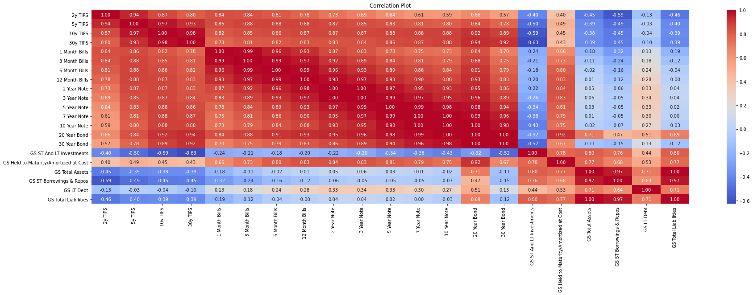

***Comments:*** *Similar to Citibank, GS’s correlation in most assets was not highly correlated with the other debt and other asset holdings which could indicate a proper diversification in assets in these areas to hedge against Interest rate risk in long term assets. However, it is interesting to see that total assets and short term borrowings had highly correlative properties with total liabilities. Nonetheless, we will investigate this exposure with Linear Regression models and T-tests to determine optimal exposure as well as any residual risk and market exposure.*

**e. Correlation plot of all J.P Morgan Bank variables, Inflation rate and Treasury Securities to determine multi-collinearity**

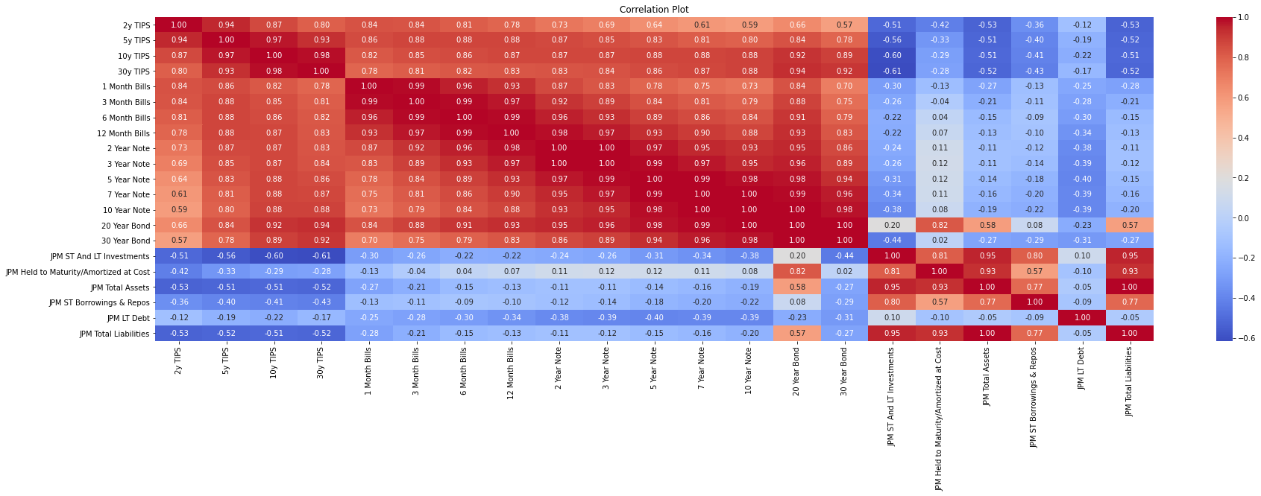

***Comments:*** *J.P Morgan’s correlation in most assets was not highly correlated with the other debt and other asset holdings which could indicate a proper diversification in assets in these areas to hedge against Interest rate risk in long term assets. However, it is interesting to see that total assets and short- and long-term assets had a high correlation of 0.95, possibly showing growth in investments when assets grew. This relationship was observed in total liabilities and Held-To-Maturity assets.*

**f. Correlation plot of all First Republic Bank variables, Inflation rate and Treasury Securities to determine multi-collinearity**

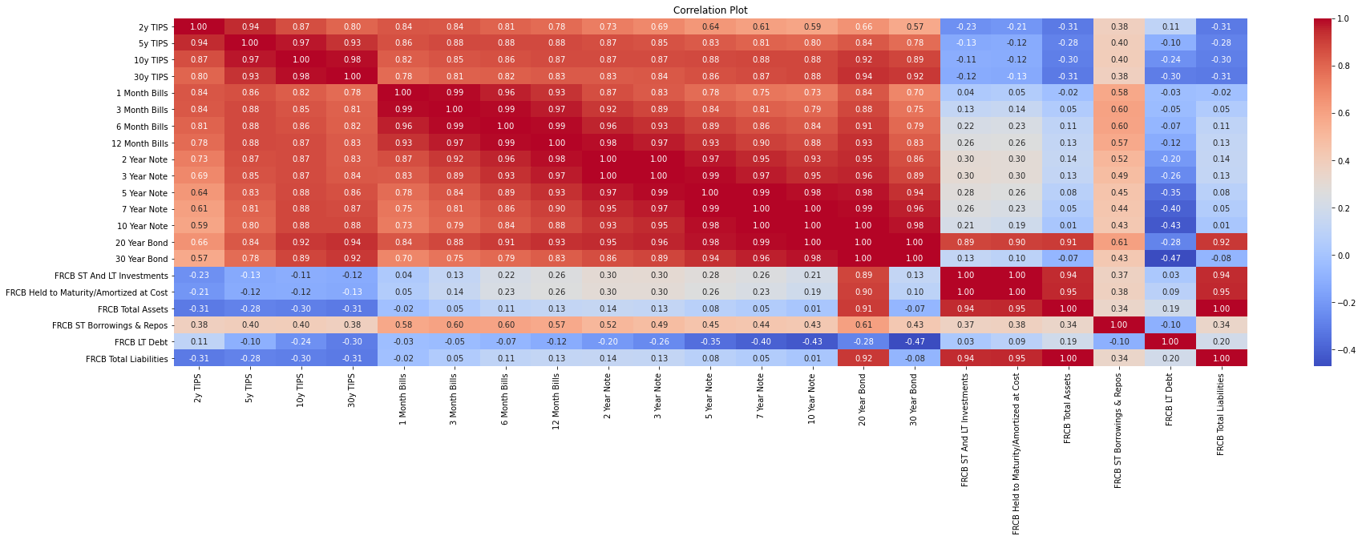

***Comments:*** *First Republic Bank was another bank that had a similar situation to SVB. Correlation in total assets was highly correlated with short and long term assets and held-t-maturity assets which could indicate lack of proper diversification in assets in these areas to hedge against Interest rate risk. However, to understand how the assets react in the macro-environment, we will use Regression models to determine profitability and relationships between interest rates and asset growth of the bank.*

**g. Correlation plot of all Morgan Stanley variables, Inflation rate and Treasury Securities to determine multi-collinearity**

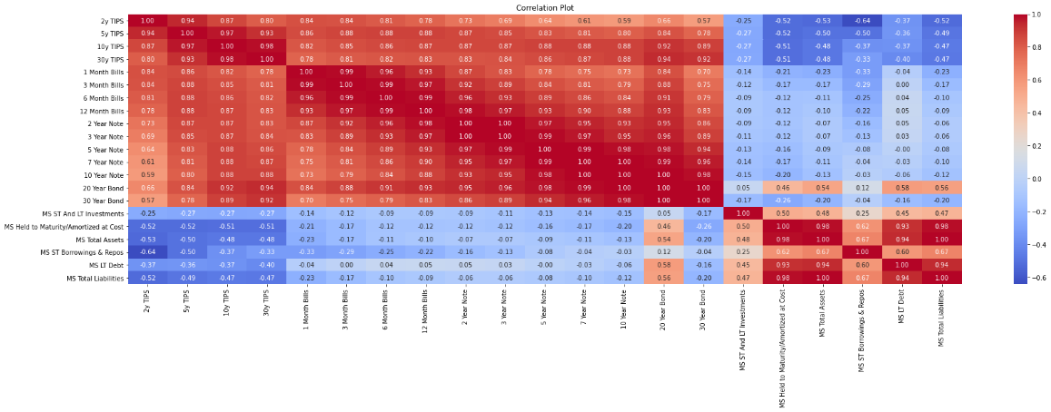

***Comments:*** *Morgan Stanley’s correlation in total assets was highly correlated with debt holdings and other asset holdings which could indicate a proper diversification within the company’s portfolio. This could indicate a health balance sheet as both assets and liabilities would grow at a similar rate. In addition, the correlation to interest rates and treasuries are lower, indicate lower market risk. Linear regression will be conducted to explore possible relationships in these assets.*

## 4.3. Appendix C: Data Mining and Results

**a. Linear regression of First Republic Bank assets and debt compared to Treasuries and Inflation Rate**

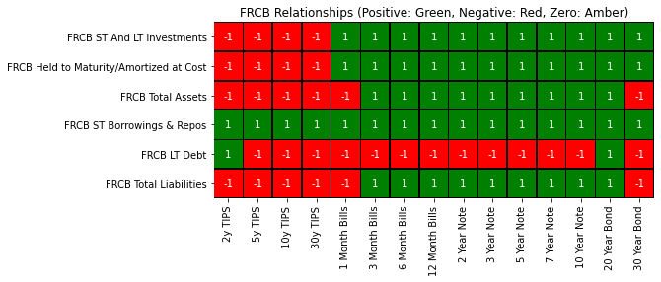

***Comments:*** *High sensitivity of FRCB’s assets was observed in a rising interest rate environment as the bank increased their HTM securities, Short- and Long-Term Investments when interest rates of the Long-term bonds and Notes (12 months bills, 5-year notes, 30 year bonds, etc) increased. This can be seen with a positive linear regression coefficient (Green boxes) of assets in relation to rising yield in the long-term treasury assets. The increased exposure could have led to the downfall of FRCB as they did not meet investor’s expected returns or hedge against the increasing interest rates and continued to purchase more long-term treasuries which had lower returns and decreased valuations.*

**b. Linear regression of Goldmann Sachs assets and debt compared to Treasuries and Inflation Rate**

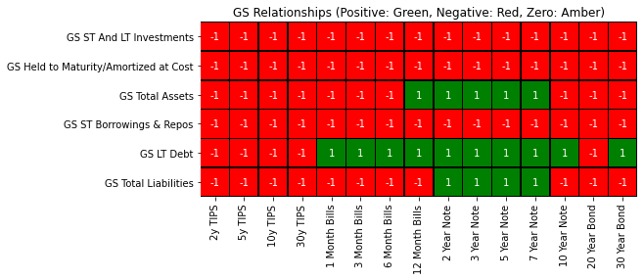

***Comments:*** *Understanding the macro-environment impacts of rising interest rates and decreasing valuations is key to maintaining better valuations in the rising rate environment. Goldmann Sachs understood the long term impacts of the interest rates and decreased exposure to treasuries, showing a negative regression coefficient over time (Past 75 quarters). This decreased their exposure to market risk and interest rate risk.*

**c. Linear regression of Citibank assets and debt compared to Treasuries and Inflation Rate**

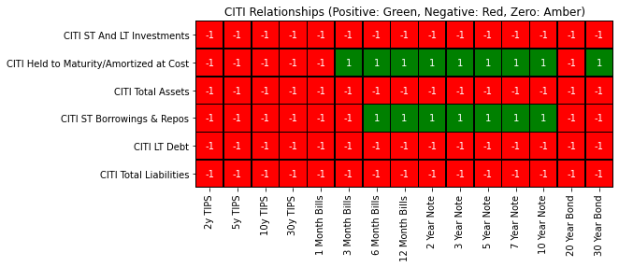

***Comments:*** *Despite having increased asset exposure to the market and rising interest rates with HTM securities having a positive coefficient, Citibank diversified their assets as shown that total assets had a negative coefficient to bonds and government notes. This showed that the overall diversification of Citibank could have consisted of assets that were non-government treasury related. The stability of Citibank through the bank run was mitigated through other investments, hence Citibank did not have as much of a huge impact as SVB when valuations of their portfolio related to decreasing valuation of treasuries decreased.*

**d. Linear regression of J.P Morgan assets and debt compared to Treasuries and Inflation Rate**

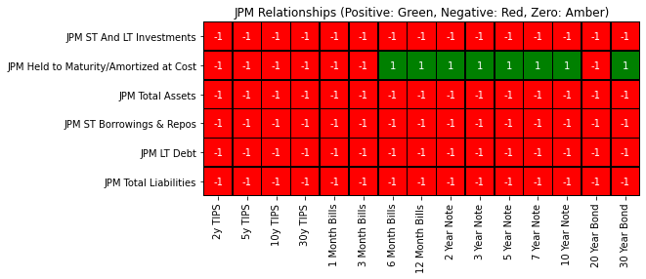

***Comments:*** *J.P Morgan significantly increased their Asset holdings for short term investment holdings amidst the rising interest rate environment, despite having a high HTM Security exposure. This shows that they hedged against market risk by diversifying portfolio to ensure that their portfolio was closer to the efficient frontier than SVB. In addition, their debt holdings had a negative relationship to government treasury yields, which shows that they maintained a healthier balance sheet compared to SVB as they kept debt holdings in check with rising interest rates to decrease interest rate risk.*

**e. Linear regression of Morgan Stanley assets and debt compared to Treasuries and Inflation Rate**

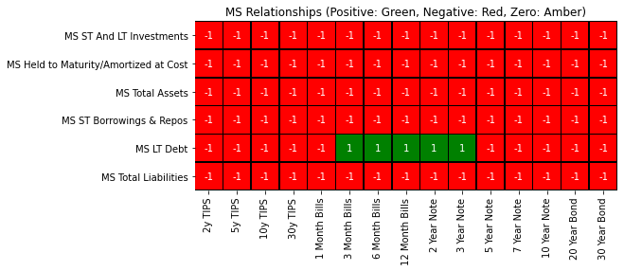

***Comments:*** *Across all banks, Morgan Stanley significantly decreased exposure to both market and interest rate risk, which improved their risk-to-reward ratio in the rising rate environment. This can be shown with decreased coefficient in the linear regression model where they had negative asset coefficient and interest rate relationship. This shows that MS understood the relationship between capital depreciation and yields rising for HTM securities/ bonds, allowing them to use the cash available for other exposure such as debt leverage as show in their Long Term Debt exposure which had a positive coefficient in the linear regression model.*

**f. Linear regression of SVB assets and debt compared to Treasuries and Inflation Rate**



***Comments:*** *SVB performed the worst for asset returns and diversifications, as their assets had multiple positive relationships to interest rates, signalling higher sensitivity to market conditions. In addition, their assets had positive correlation and coefficients for all treasury notes. This means that there is a direct positive relationship between their HTM securities and long term assets, showing lack of diversification. hence their HTM assets may experience a decline in market value when yields increase, leading to a positive correlation between valuations and interest rates. This can also be validated in SVB’s efficiency growth ratio which is the lowest (negative). This shows low returns when compared to peers and is close to the lower limit of the 95% confidence interval which shows decline in asset returns, as asset utilization is not well managed. This can be shown in* ***Question 1.3*** *of this report.*

**g. Linear regression of BOFA assets and debt compared to Treasuries and Inflation Rate**

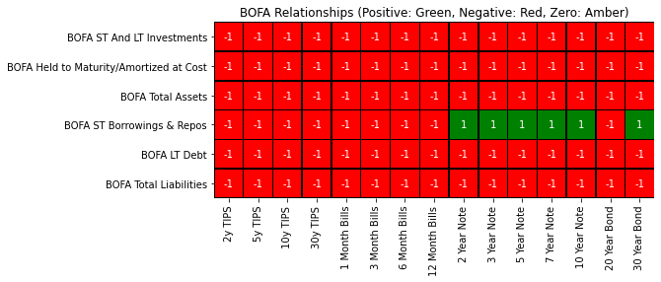

***Comments:*** *Similar to all other non-defaulted US Banks (Goldmann Sachs, Morgan Stanley, Citibank, J.P Morgan), BOFA decreased exposure to market and interest rate risk by diluting HTM and Short term assets related to interest rate and treasuries as seen by the negative correlation. This shows that they reduced possible exposure to assets that are susceptible to treasuries in the high interest environment that could lead to decreased future valuations in treasuries. In addition, they leveraged on net interest margins to obtain positive interest margins growth and focused on external cashflows from loaning out money to diversify their source of income.* ***Net interest margin growth rate is 0.21%.*** *This decreased their exposure to market risk and interest rate risk.*

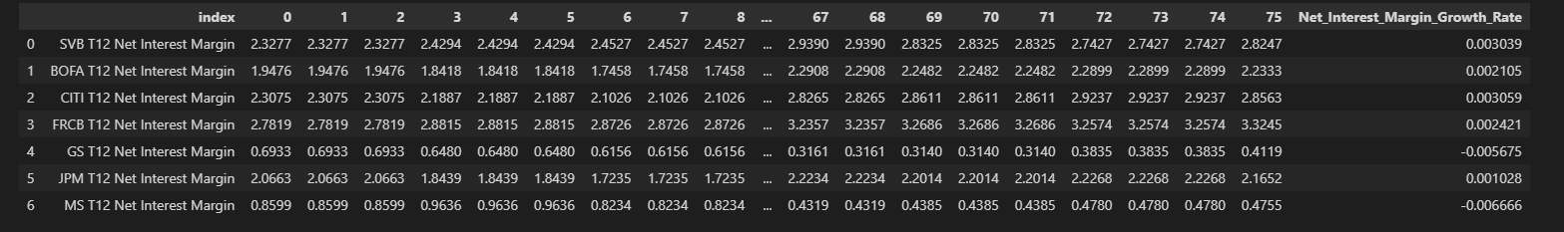

**h. Linear regression of SVB assets and debt compared to Treasuries and Inflation Rate**



***Comments:*** *Most of the assets, debt and financial figures in the datasets used display a positive or linear relationship with interest and treasury yields, this can be observed in greater detail in* ***Figures a to g****.*

## 4.4. Appendix D: Code Snippets and Functions

**a. Random Forest Analysis of macro-Economic Conditions leading to Bank Run/ Bank Default**

Step 1: Data Cleaning and data quality check

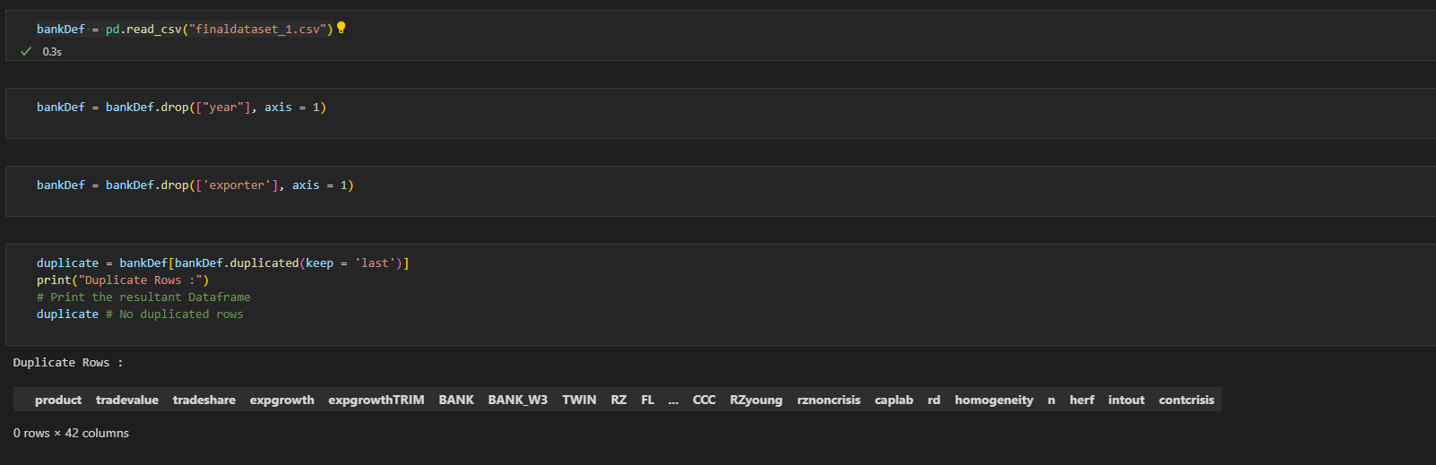

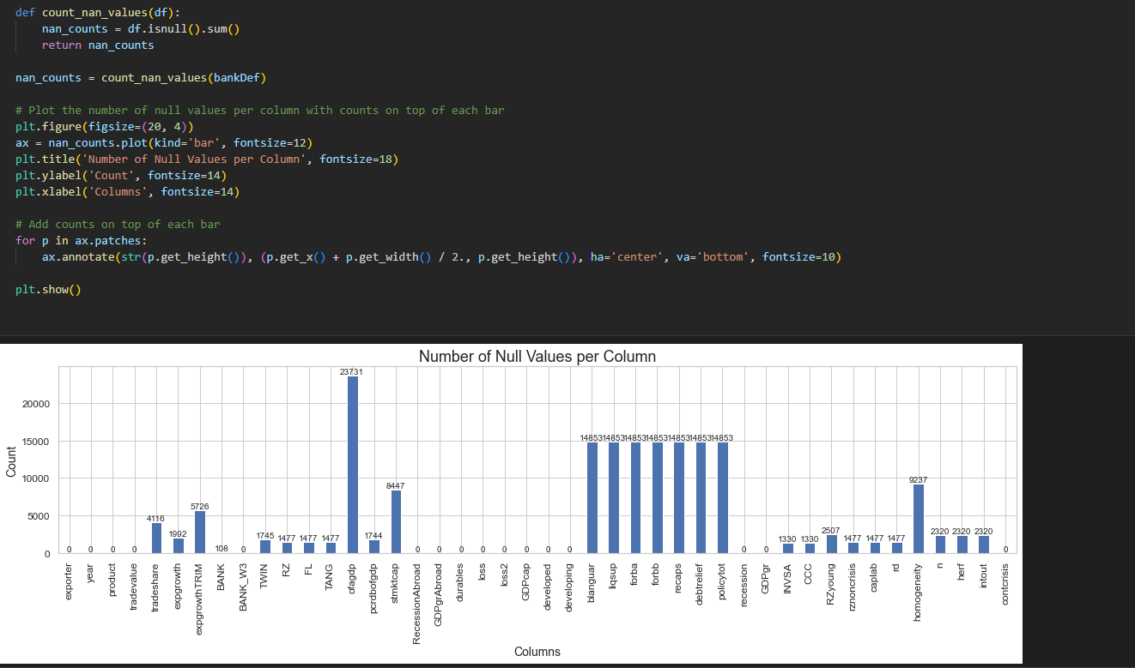

Dropping of columns not needed in feature selection and data engineering. Check for missing data and duplicate rows. We can see that most of these columns contain missing data.

Step 2: Use missForest Algorithm to impute values (Boot strap and Bag values using random Forest to impute values based on suitable values in other columns)

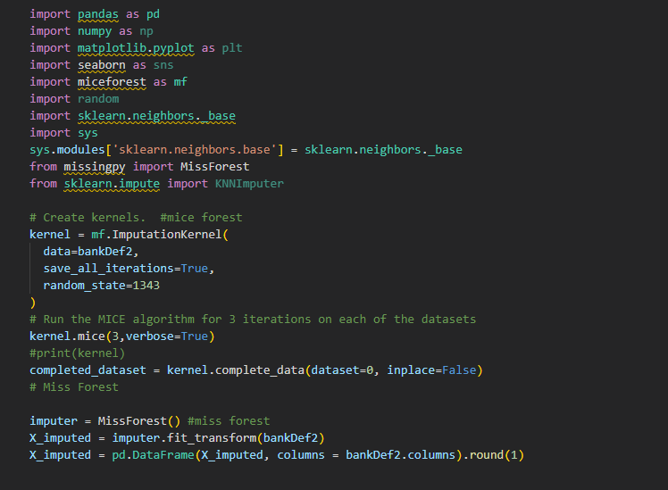

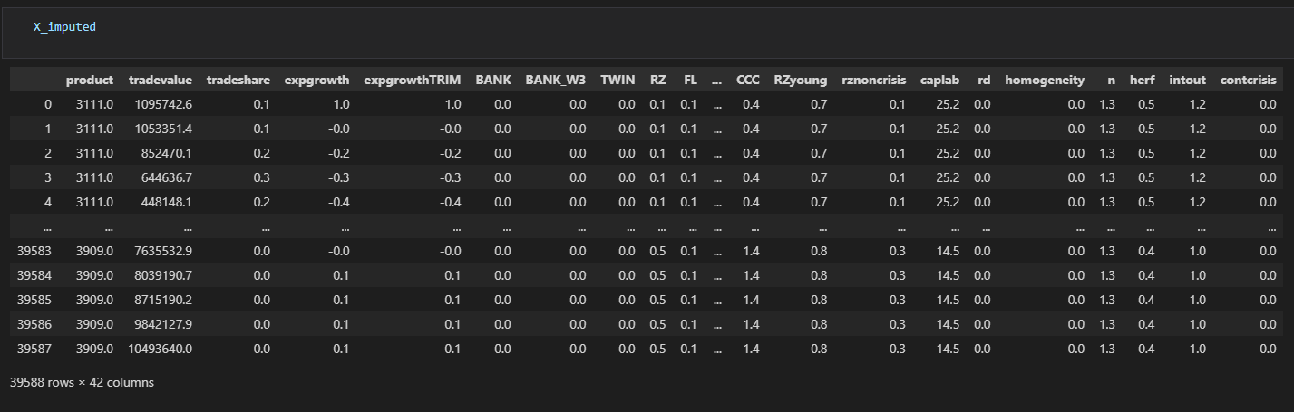

MissForest Algorithm provides a better judgement of the data imputed through sampling of data present in current dataset.

Step 3: Check for NA/missing values in new dataset (No missing values present)

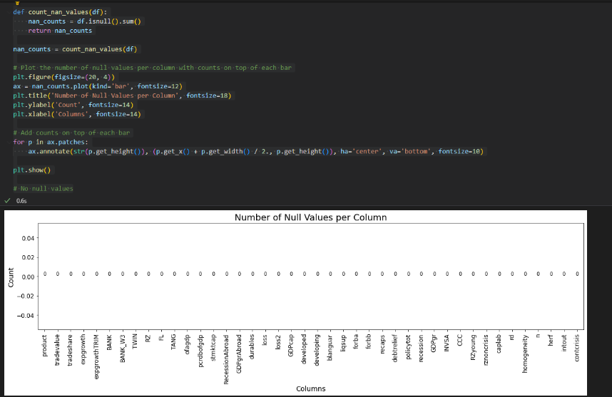

Step 4: Subset dataset and feature engineering

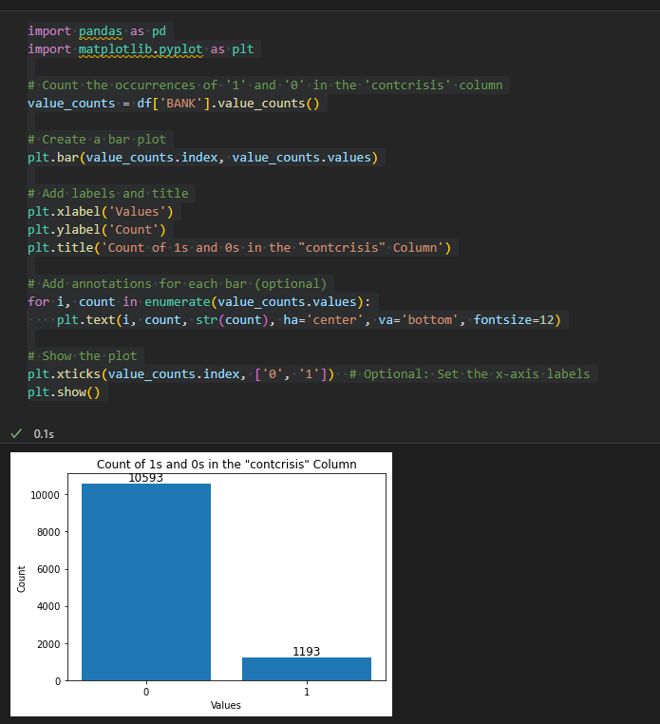 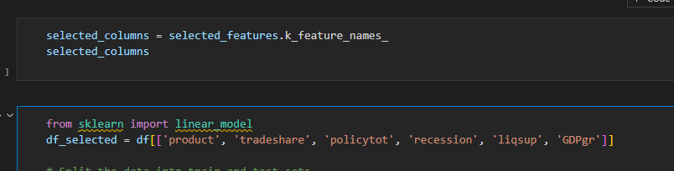

Using logistic Regression, we subset the data using confidence interval of 95% to obtain Country Product, Country’s Trade share, policytotal (Capital Adequacy Tier 1 Ratio), Recession probability, LiqSup (Quick Ratio of the bank) and GDP growth rate to predict the probability of bank’s default. The rows were further subset using the years that bank defaults were prevalent. *(See below)*

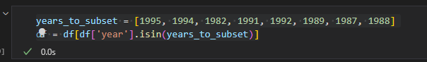

Step 5: Run Random Forest Classifier to predict bank default and determine accuracy

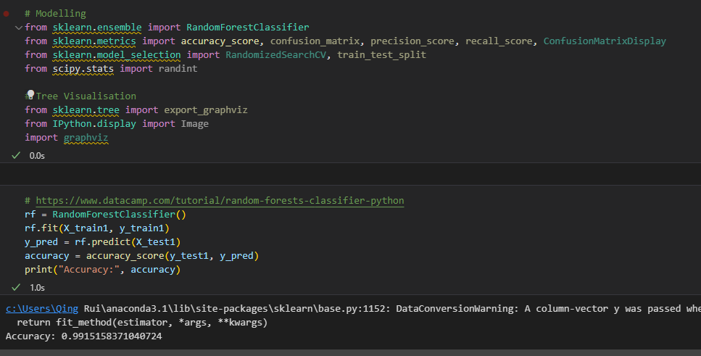

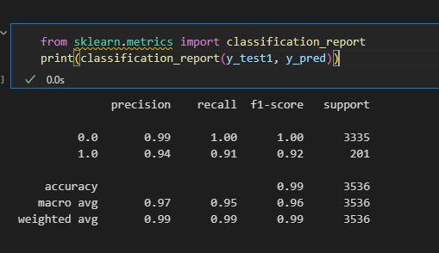

Random Forest showed high predictability and accuracy in predicting both classes (0 = No Default, 1 = Default).

Step 6: Feature importance for future investigations

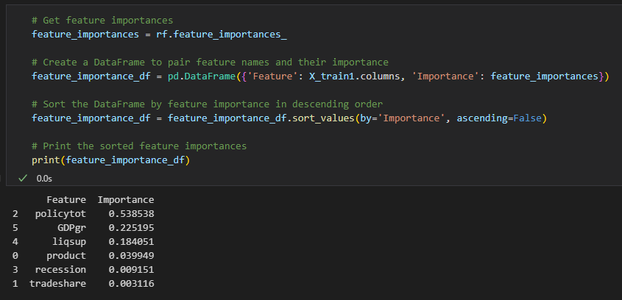

We can observe that Capital Adequacy Tier 1 Ratio *(policytot)* is important in reducing bank default, as pointed out by the model. However, the bank is also susceptible to GDP growth of the country. Liquidity metrics such as Quick Ratio is also important in reducing the default of the bank.

Step 7: User input and modelling for prediction

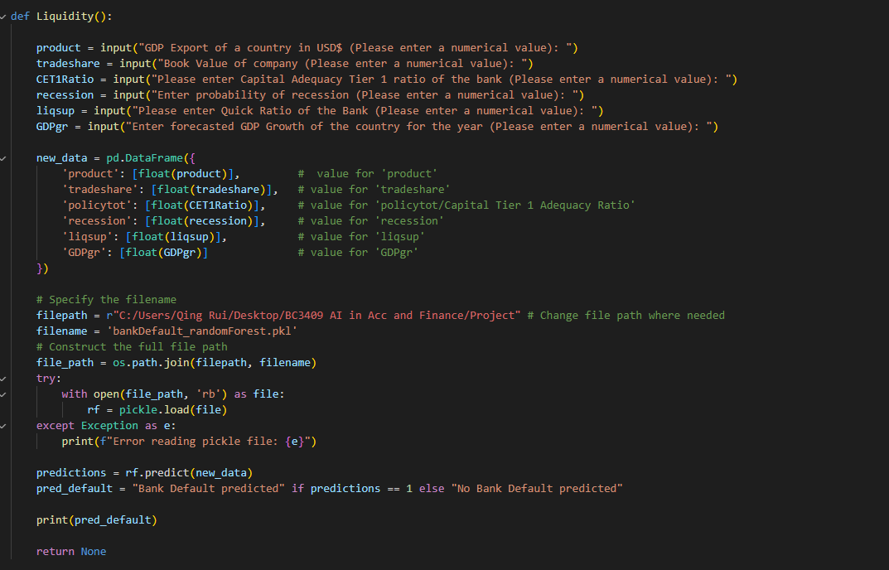

Using the model above, we pickled the model into a pickle file *(bankDefault_randomForest.pkl)* to allow users/readers of this report to determine future bank defaults using the inputs **(See red Box)**, allowing users to reduce risk through a data driven approach to understand lapses within the bank and how the bank can pivot to reduce market risk and interest rate risk while increasing their liquidity to ease consumers worries. The model also provides transparency for users and bank managements to determine if inherent bank run risk is present so they can adjust according to internal and external risk within and outside of the bank.

**b. Yield Curve Analysis of banks and Quantitative Benchmarks**

Using a Linear Regression model, we determined that the optimal confidence interval to conduct the student T-test was at 95% confidence interval. We then stress tested SVB’s EPS, Trailing 12 months Net Interest Margin and Efficiency Ratio to peer banks such as Goldmann Sachs, BOFA, J.P Morgan, First Republic Bank, Morgan Stanley, Citibank. Our analysis and codes are as follows:

EPS Stress test using T-test

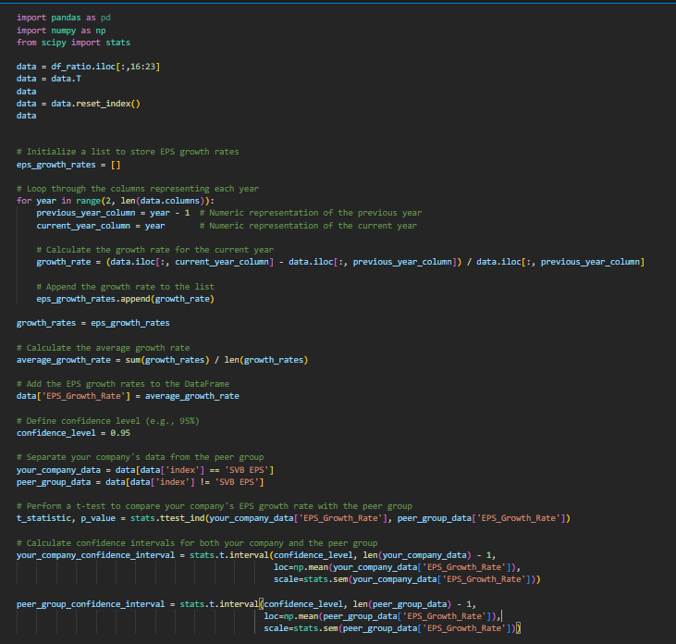

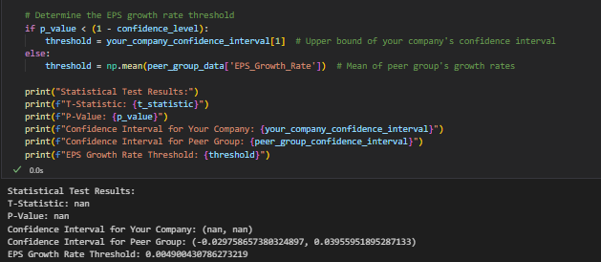

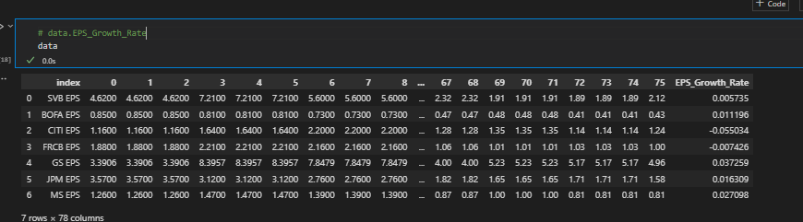

Analysis of SVB’s EPS growth rate over 75 quarters showed that they performed the third worst compared to 6 other US banks. This could be due to lower Return on their HTM Securities and other investments, which was a precursor sign to the bank run. This is despite SVB’s EPS being in the acceptable 95% Confidence Interval range of the T-statistic. We will investigate other financial statistics such as Efficiency Ratio and Net Interest Margin to validate this result.

Efficiency Ratio

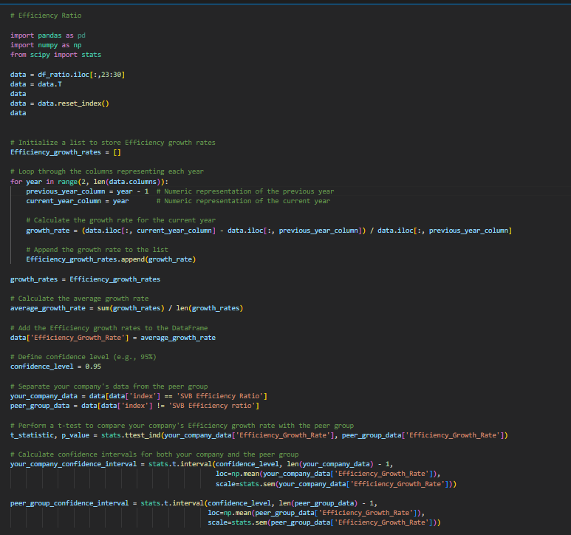

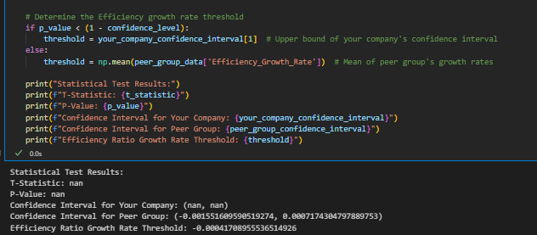

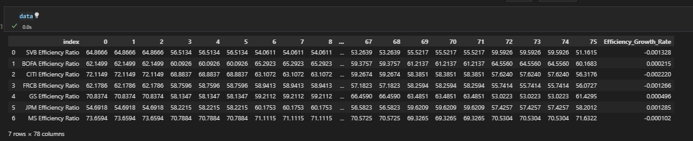

SVB’s Efficiency Ratio performed the worst in terms of all banks. First Republic Bank, which was another bank that was subjected to failure due to similar situation as SVB, had the second lowest in efficiency ratio. This shows that using a quantitative approach, we can visualize differences between possible bank runs as these banks are more likely to underutilize their assets and have a lower return on investment, leading to a lower efficiency ratio as a precursor to bank run. In addition, despite a 95% confidence interval, SVB’s efficiency growth ratio of

-0.001328 was close to the lower limit of -0.00155160. Banks that have extremely low values close to their lower confidence limits are more likely to fail the t-statistics of being efficient and hence more likely to result in bank failures. (2-tailed hypothesis test)

Trailing 12 Months (T12) Net Interest Margin

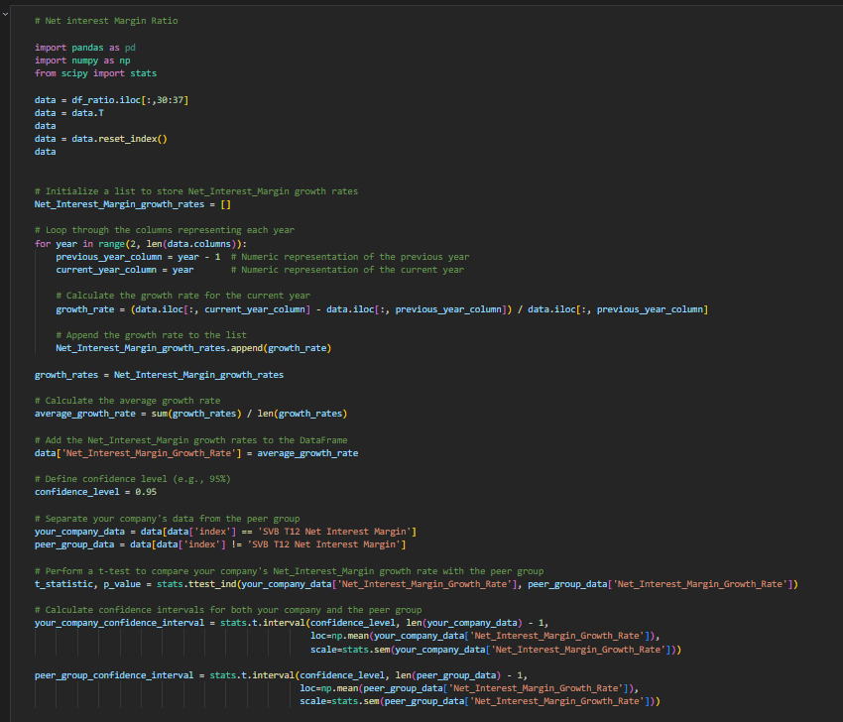

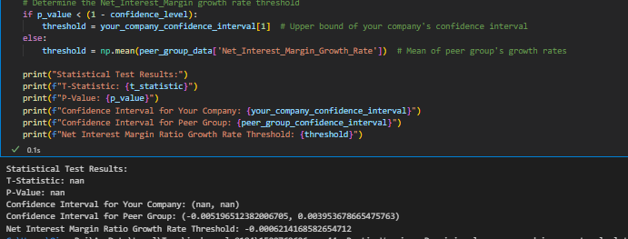

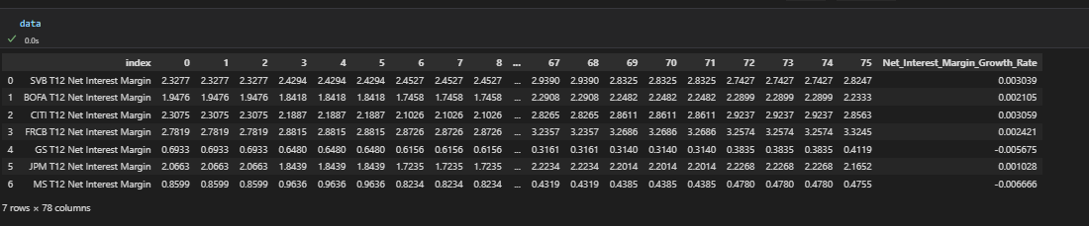

T12 Net Interest margin for SVB at a 95% Confidence Interval showed that net interest margin from operating activities such as Loaning out cash to borrowers was at a healthy margin for SVB. However, the T12 Net interest margin is not the best as it is the 4th highest amongst all other peer banks. Despite this, markets react more heavily to negative news as shown in lower efficiency ratios and lower assets returns. The interest margin growth was not adequate enough to offset the decrease in efficiency ratio over the periods observed.

Lastly, using the data gathered from the regression models and the T-tests, our team devised a quantitative model to benchmark adequacy of the company in these aspects using a percentile score from ***scipy stats*** package in python. 3 key inputs will be required:

* Expected or Actual EPS value of the company
* Expected or Actual Efficiency Growth Rate (in %) of the company
* Expected or Actual Net Interest Margin of the company

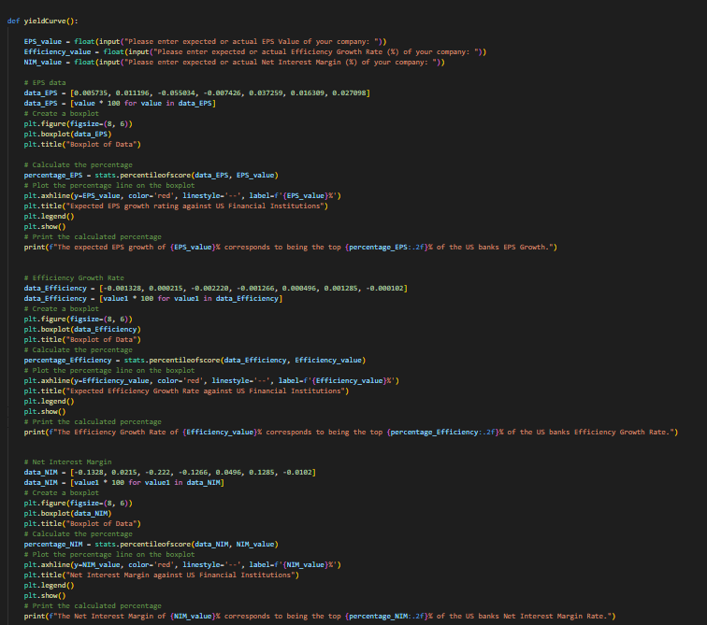

Using this code and scorecard system, we can see that we are able to benchmark the bank which will allow the bank to understand its relative positive compared to peer groups to optimize assets and financial stability/ratios where possible. *This is done through the stock app where users can input the expected or actual EPS, Efficiency ratios and net interest margins of the target bank to gauge its performance:*

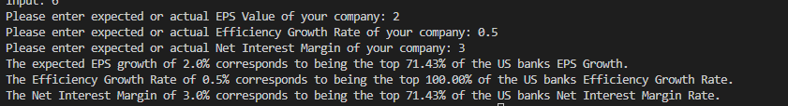

With an expected EPS growth of 3%, we can see that the bank would correspond to the top 85% of its peer group and has a healthy EPS growth/EPS in the financial sector.

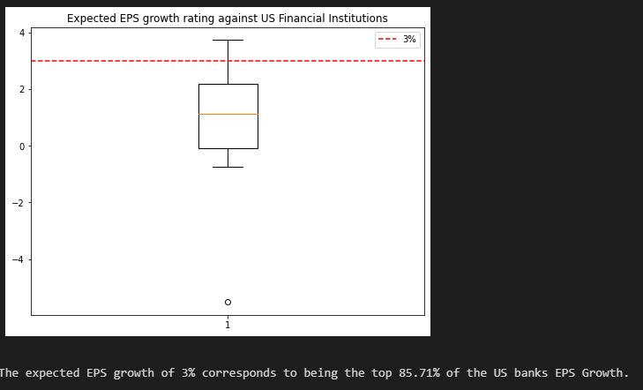

With an asset efficiency ratio of 0.1%, the financial institution would also be in the top 85% of its per group and is using assets well to generate returns as it is above the average (Mean) and 75% percentile of their peer group.

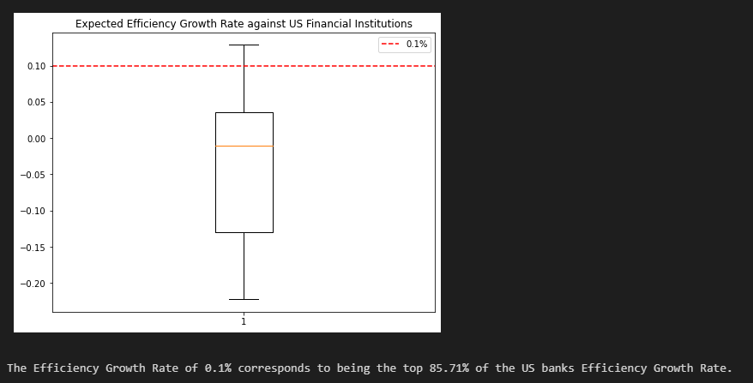

With a net interest margin of 3%, the bank is at the top 71% of the peer group, this is also an optimal Net Interest Margin to have, and banks/financial institutions can use this as a gauge for Net Interest margin performance.

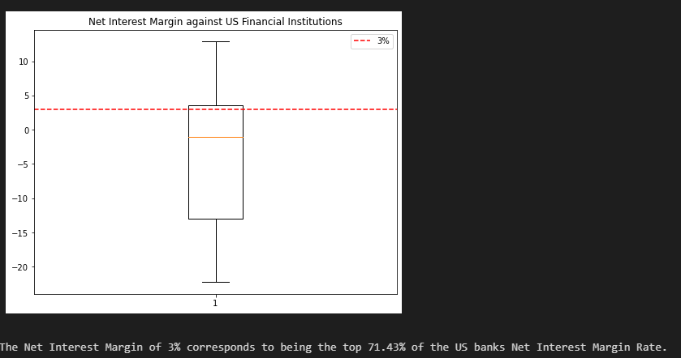

Yield Curve models (Nelson-Siegel Model)

In the Nelson-Siegel model, we used parameters beta0, beta1, beta2, and tau to describe the shape and characteristics of the yield curve.

* Beta0 (β0): This represents the long-term interest rate or the level of the yield curve. It represents the theoretical long-term yield to which the yield curve converges as the time to maturity approaches infinity. In other terms, it is the curve's horizontal shift. An increased β0 indicates a greater forecasted long-term interest rate.
* Beta1 (β1): This variable affects short-term interest rates and regulates the yield curve's initial slope. It determines the initial steepness of the yield curve's slope. Higher short-term variations in yields at β1 levels results in initial steepness of the slope.
* Beta2 (β2): β2 controls the curvature of the yield curve, and a higher β2 value indicates a more pronounced curvature. It modifies the yield curve's form over the medium term depending on the parameter set, producing a hump. The yield curve's curvature is determined by β2, and a larger β2 number denotes a more pronounced curvature.
* Tau (τ): The time factor, or tau, is also referred to as the decay factor. It shows how quickly yields converge to the long-term rate of 0 as the time to maturity lengthens. A smaller denotes a faster convergence to the long-term rate, causing the yield curve's knee to be more apparent.

Using optimized parameters according to yield and maturity of the treasuries, we can aim to predict the changes in the yield curve and determine appropriate long-term yield for the treasuries that SVB can hold to optimize their returns. A higher expected yield means that the treasury is more subjected to interest rates fluctuation and higher probability of decreased valuations, leading to selling of the HTM Securities at a loss. *The model of the yield curve of SVB’s possible treasuries are as follows:*

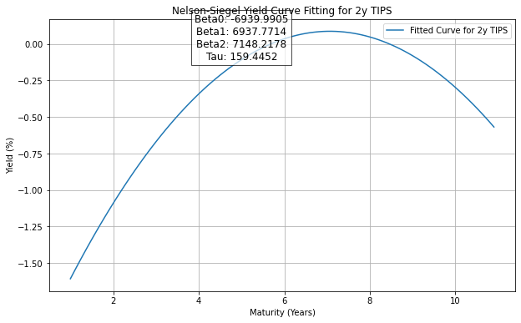

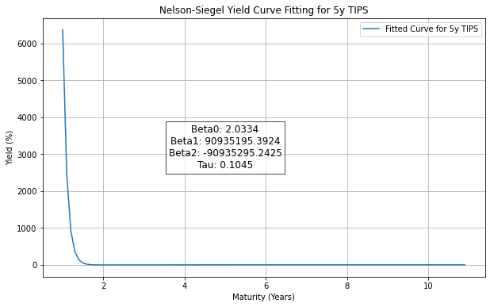

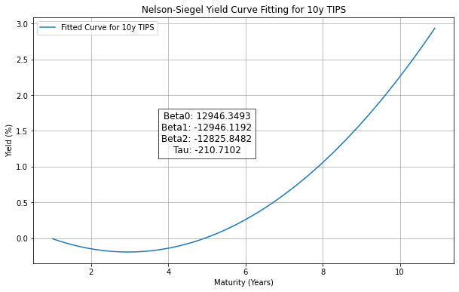

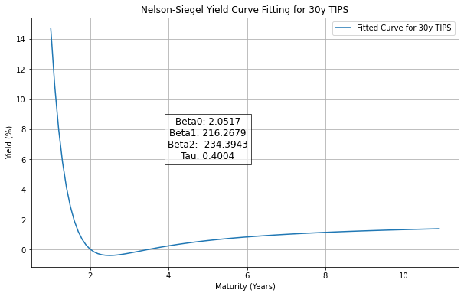

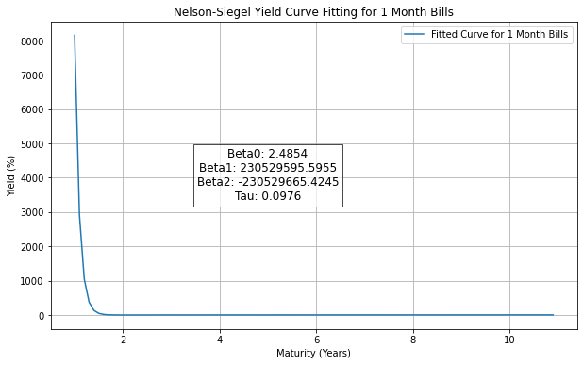

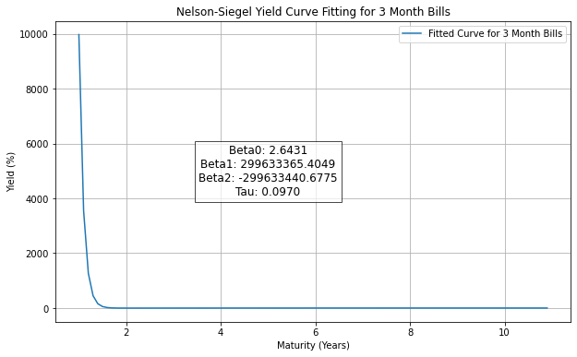

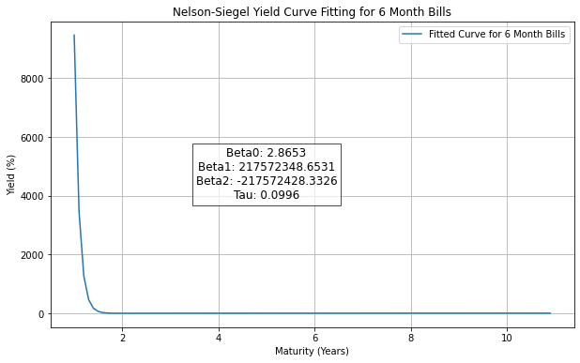

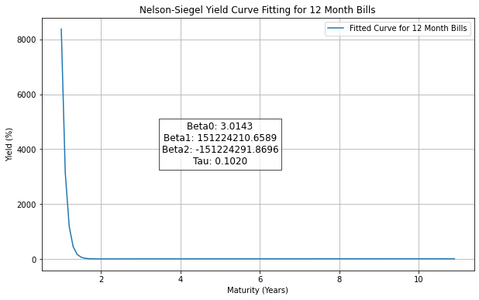

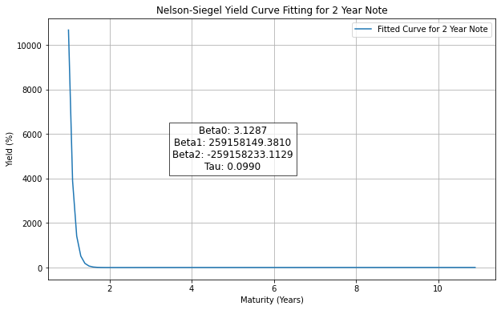

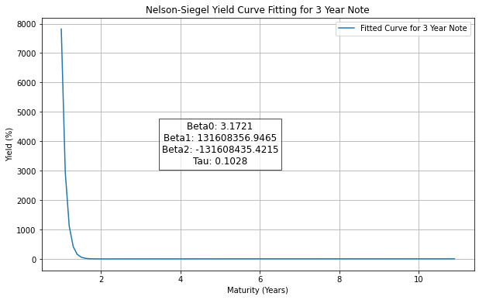

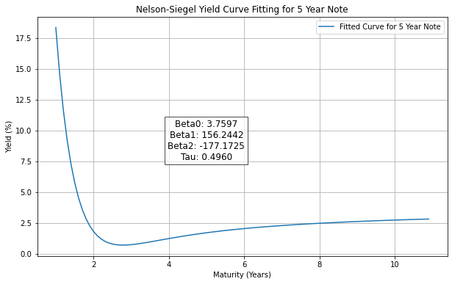

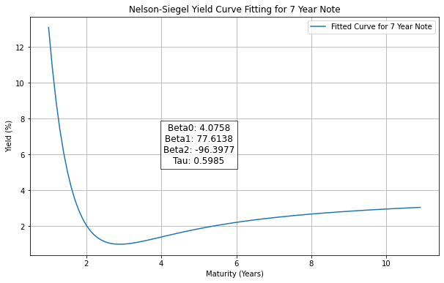

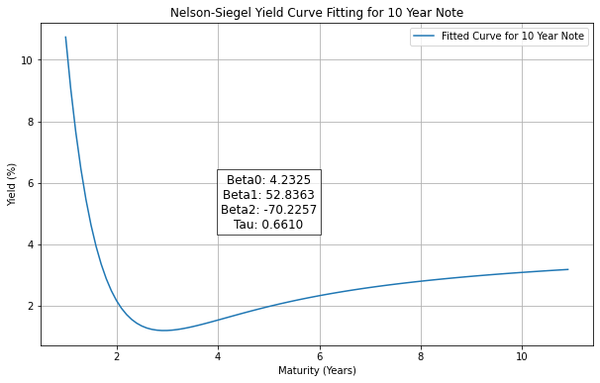

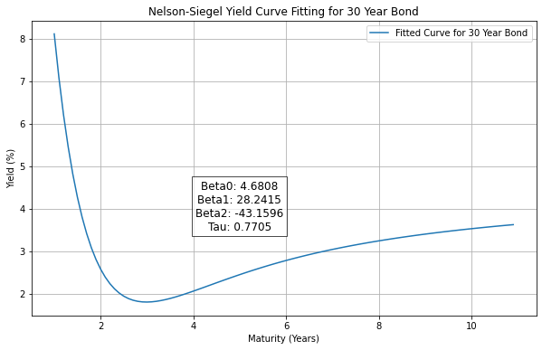

Thie Nelson Siegel yield curve model is done by analyzing the 4 optimized parameters and fitting them onto the curve using the formula below (Smoothing parameters are also included to make each iteration generate a curved yield using yield decay:



The code is then executed to generate the iterations and plots above as follows:

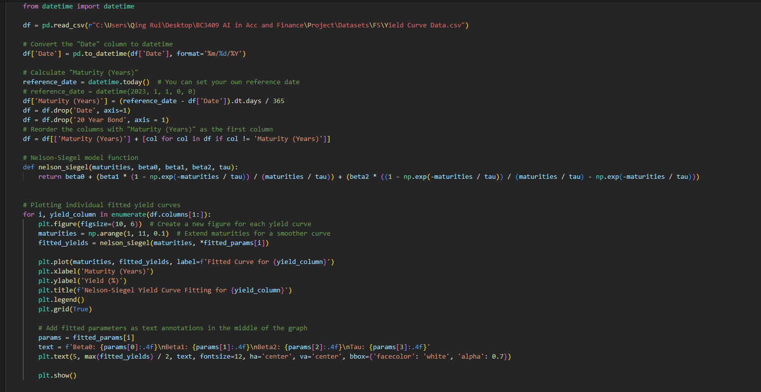

Analyzing all the Beta0 *(See below)*, we can see that the long-term assets such as 7 year note, 10 year note and 30 year bond have the highest yield, but this could indicate a risk of default in short term from creditors as valuations for treasuries are decreased when yield rise, resulting in SVB having to sell their assets (Treasuries) at a loss. Instead, SVB can optimize their portfolio by rebalancing with 5Y and 30Y Treasury Inflation Protected Securities (TIPS) which have lower yields as their prices would not be impacted by the rising environment as much, and the valuations would remain stable or not decrease as much as the long term notes that they currently hold. Another alternative would be to purchase short term securities such as 1-, 3-, 6- or 12-month Bills which have lower yields but provide greater liquidity. This method of diversification would allow SVB to remain stable and could have resulted in lower risk of bank run through an improved balance sheet.

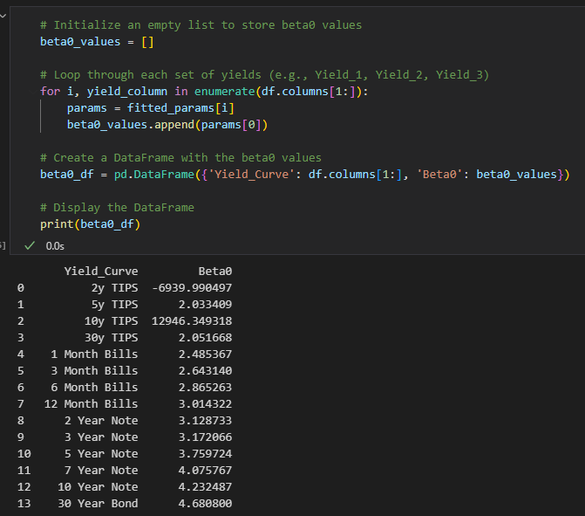

**c. Portfolio Stress test and Monte Carlo Analysis for Efficient Frontier model**

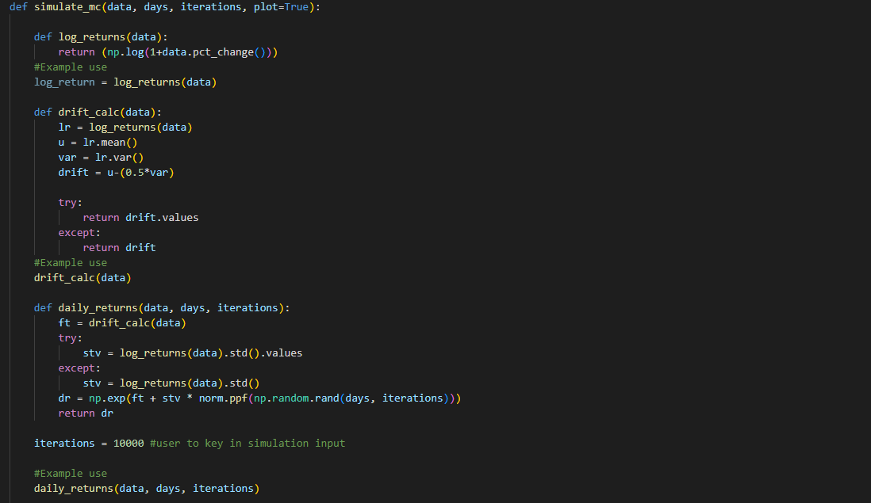

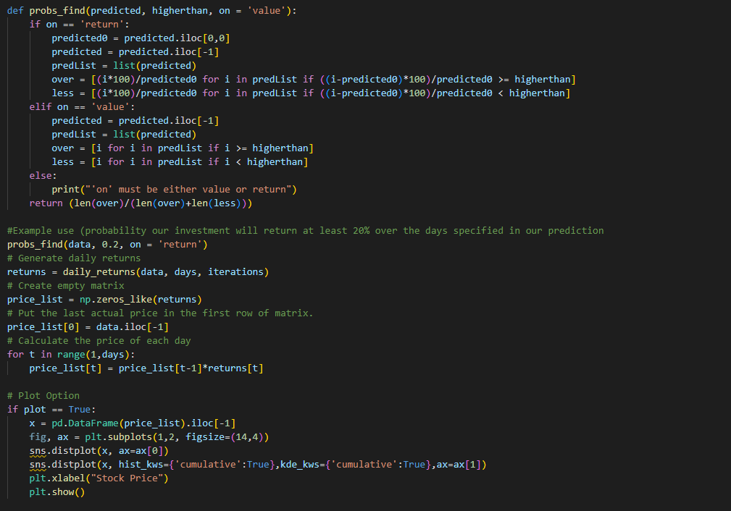

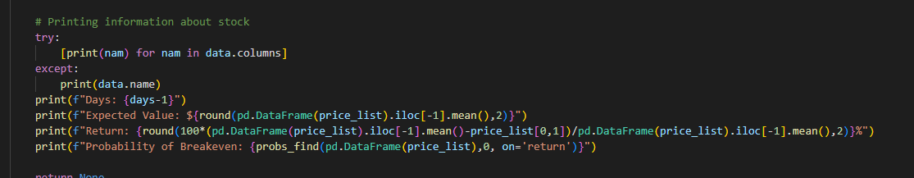

Using drifts in portfolio prices over historical 20 years, we analyze various movements in asset prices and market conditions (GFC in FY2008, Asian Financial Crisis in 1997, COVID pandemic in FY2019) and the current interest rate hikes to stimulate 10,000 portfolios to analyse how market conditions can impact stock prices and value and breakeven probability. This is done using an exponential/loglinear function to mimic tail risk, where unexpected losses may occur in rare scenarios. An example of the intermediary output is shown as below:

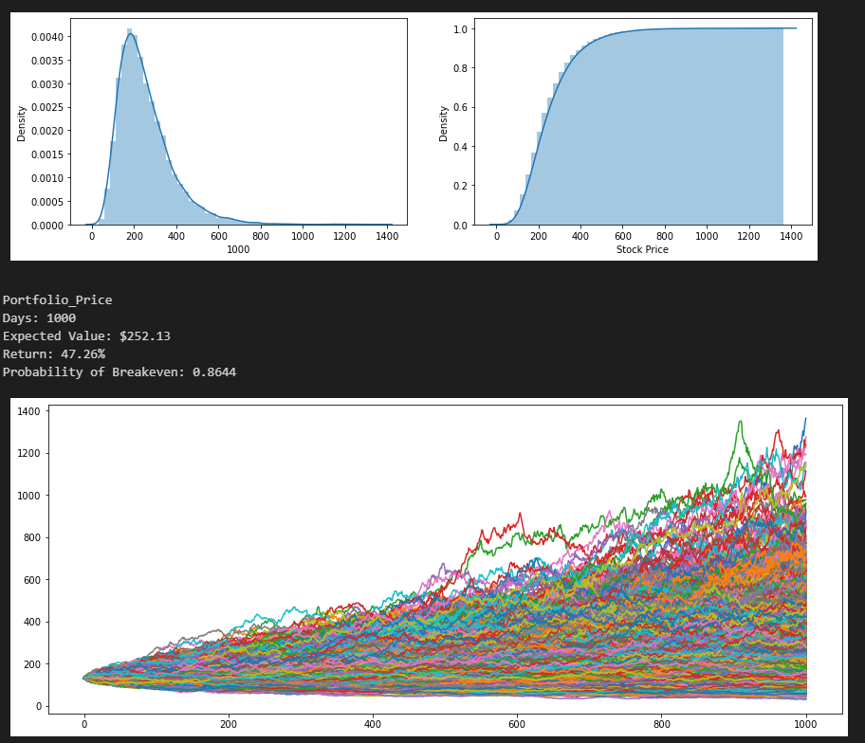

Subsequently, we use a data driven approach for portfolio rebalancing using intra-day signals using the adjusted close prices to rebalance portfolios using the standard deviations and sharpe ratio of each stock to determine optimal weights according to current macro economic conditions to adjust returns as per user setting. *The preset expected returns are set at 20% of current portfolio valuation*.

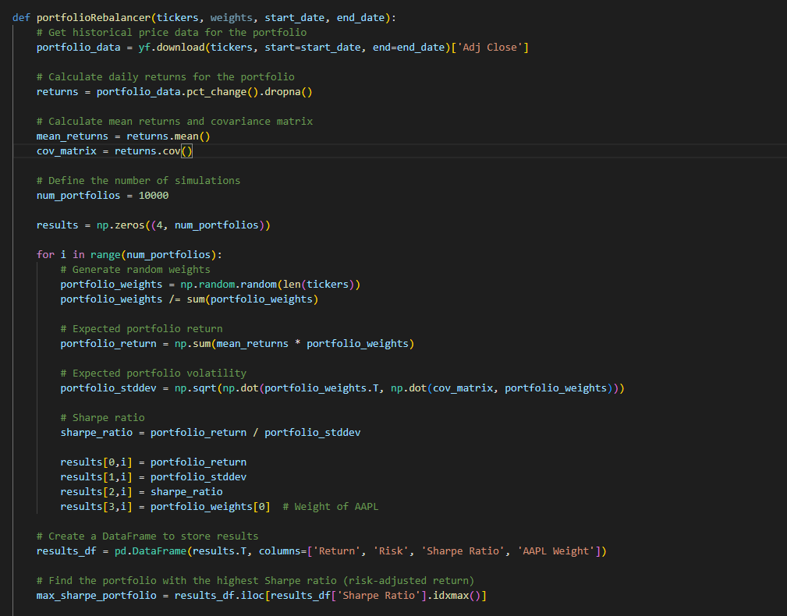

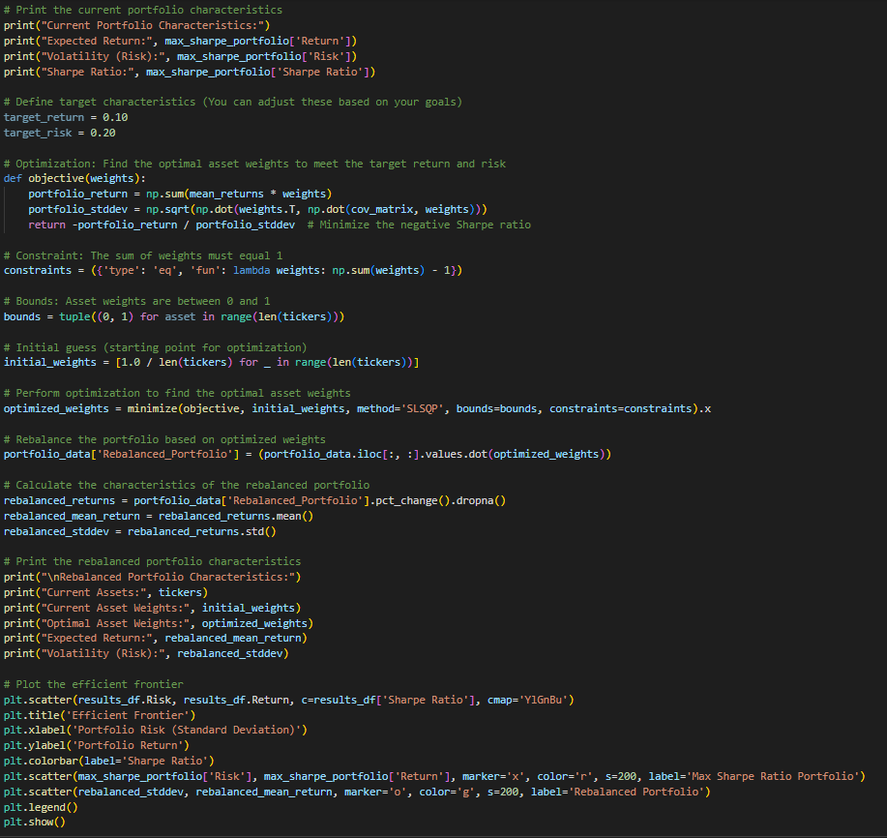

Using distribution modelling and traditional portfolio techniques such as Sharpe ratio, we can optimize asset holdings which can be applied to SVB’s scenarios using historical returns and macroeconomic conditions to determine if the bank is overweight or underweight in certain circumstances that can lead to a bank run. *An example of the output using a portfolio comprising of AAPL, MSFT and GOOGL is as shown below:*

 

Using this data driven approach, it allows the bank to determine if certain weights or allocation is suitable for the portfolio and to lower asset exposure where needed to optimize returns and lower risk, improving the risk-reward ratio which is the goal of the efficient frontier model.

**d. AI Chatbot and news scraping using Google PALM API**

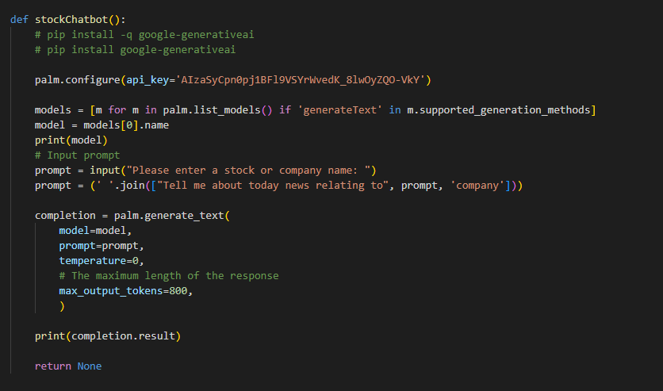

Google PALM API was used in this project to generate news and outputs based on a company that the user was interested in. For example, Apple Company was used, and this provide a single touchpoint for the user to obtain news sources through the API and interaction with the chatbot.

The output is as follows:

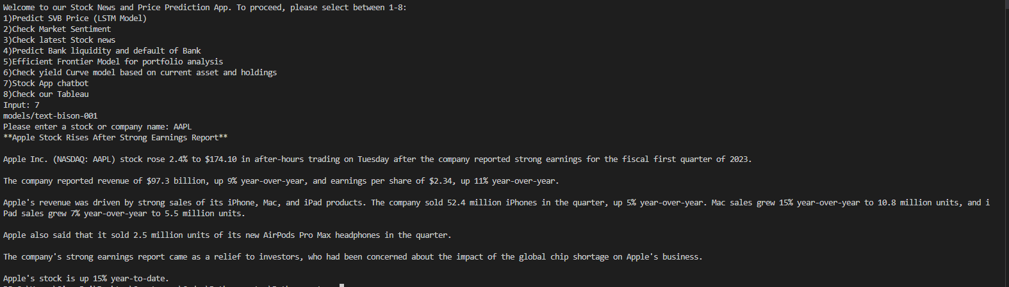

**e. Sentiment Analysis and Tokenization of keywords (NLP)**

Natural Language Processing was used on news articles ***(Using NewsAPI)*** to obtain sentiment analysis on various news and embedded hyperlinks for a single touchpoint for users to obtain current market analysis on a target company. In this example, Apple company was used to generate news and determine positivity of the news. Pre-processing was done based on 2 keyword training and testing data *vadar_lexicon and punkt*, while the output was validated on the Apple news headlines.

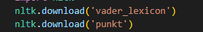

The code is as follows:

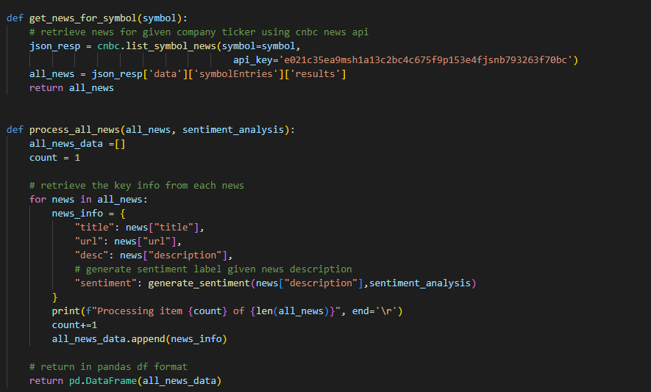

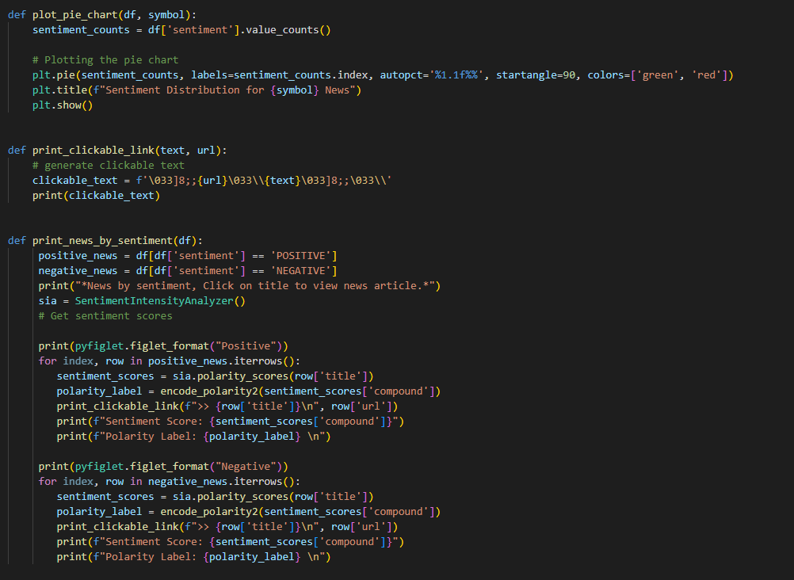

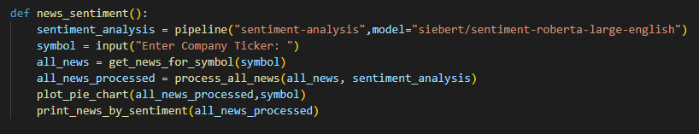

The output is as follows:

**

We can see that Apple has more positive news on this particular day, signalling possible increase in stock price for Apple

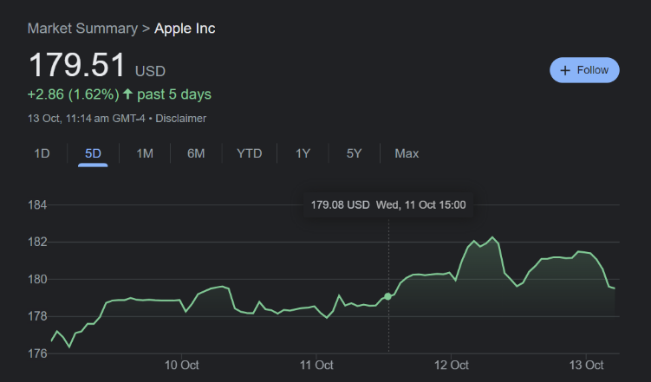

 

Each news article is given an embedded hyperlink and a sentiment score, sentiment score are categorized according to <0 which shows negative news, 0 which is neutral news, and >0 which shows positive news. This is then aggregated into the pie chart as shown above.